NOTICE OF COMPLETE APPLICATION FOR
A PLAN OF SUBDIVISION APPLICATION

TAKE NOTICE that the Planning and Community Development Committee of the Corporation of the County of Grey has received an application for approval of a Plan of Subdivision and deemed it to be a complete application.

The proposed Plan of Subdivision (County File # 42T -2012-01) is located at:

Part of Lots 158, 173 and 174, RP 529, Town of The Blue Mountains (Geographic Township of Collingwood)

The Plan of Subdivision application proposes to create a total of 33 blocks, including: seven (7) open space blocks, twelve (12) semi-detached blocks (24 semi-detached units), twelve (12) townhouse blocks (65 townhouse units), and two (2) villa blocks (128 villa units) totaling 217 residential units. Five (5) of the units are proposed as model homes on Lot 174, RP 529.

A Key Map is provided below to show the location of the lands to which the proposed Plan of Subdivision pertains.
IF AND WHEN A PUBLIC MEETING is scheduled, you will be notified by the Town of The Blue Mountains in accordance with Provincial regulations.
ADDITIONAL information relating to the proposed Plan of Subdivision may be obtained by contacting the County or by visiting:
Link to Eden Oak - County file no. 42T-2012-01
The file is also available for public inspection between the times of 8:30 AM and 4:30 PM at the office address listed below.
IF YOU WISH TO BE NOTIFIED of the decision of the County of Grey in respect of the proposed Plan of Subdivision, you must make a written request to the County of Grey at the address listed below.
DATED AT Owen Sound this 18th day of June, 2012.
County of Grey
595 9th Ave. East
Owen Sound, Ontario
N4K 3E3
Phone: 519-376-2205 Toll Free: 1-800-567-4739
Fax: 519-376-7970
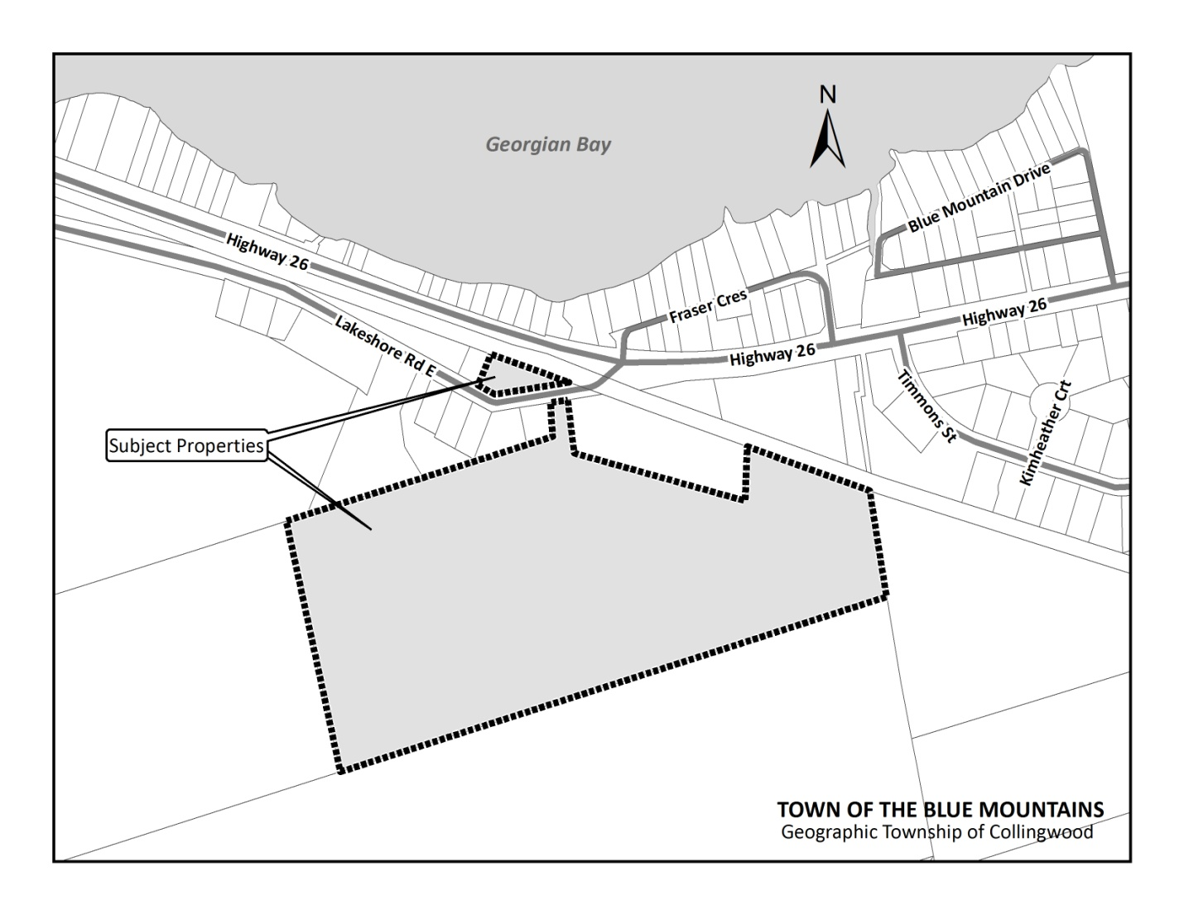

KEY MAP

