Grey County Logo Committee Report

# Report TR-CW-08-17

**To**: Warden Barfoot and Members of Grey County Council

**From**: Pat Hoy, Director of Transportation Services

**Meeting Date:** March 9, 2017

**Subject: Dedicated Road Signs**

**Status**: Recommendation adopted by Committee as presented per Resolution CW40-17; Endorsed by County Council March 23, 2017 per Resolution CC13-17;

## Recommendation

1. **That Report TR-CW-08-17 be received and;**
2. **That Transportation Services staff install tabs on existing route markers designating alternative road names at the time that the large existing signs require replacement.**

## Background

There are currently 7 Grey County Roads which have been given alternate dedicated names via by-law in addition to the Grey Road number. Some of the originally installed large signs are in poor condition and require replacement. Transportation Services would like to maintain recognition of the named roads as the past councils have felt that the public service contribution was significant.

The existing signs are 152cm by 60cm (approximately 6ft by 2ft) and are installed on 2 posts. The current cost to make and install the large signs is approximately $500, including posts. The large signs are damaged more frequently than smaller tabs on existing route markers. Grey County replaces approximately 2 of these large signs per year.

Transportation Services is proposing smaller tabs along every route marker of the dedicated section, rather than a few large signs. The tabs are 60cm by 30cm (approximately 2ft by 1ft) and cost approximately $70 to make and install.

There are currently 25 large signs on Grey County Roads throughout the County. Identification of these roads can sometimes not be seen depending on where traffic enters the road. If Grey County replaced the large signs with the smaller tabs, there would be 60 tabs added to existing route markers.

The additional tabs could potentially increase the profile of the road name as they will be on every route marker and not just in some areas as the large signs currently are. There will be less maintenance costs for the tabs. Transportation Services is recommending that when the road signs require replacement, the smaller tabs be added to all route markers along the designated road.

## Financial/Staffing/Legal/Information Technology Considerations

It is anticipated that Grey County could realize savings of $8,300 (over the life cycle of the signs) and ongoing maintenance costs by installing the smaller tabs rather than the large signs.

## Link to Strategic Goals/Priorities

The Values Statement of the approved Corporate Strategic Plan includes Fiscal Responsibility.

## Attachments

Dedicated Road Sign Replacement Summary

Proposed Dedicated Road Sign Templates

Respectfully submitted by,

Patrick Hoy  
Director of Transportation Services

## Dedicated Road Sign Replacement Summary

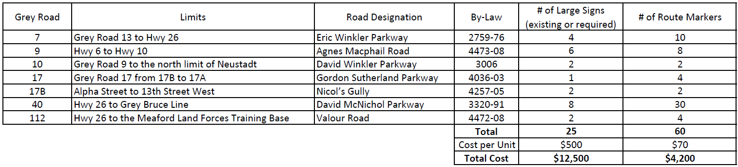

## Proposed Dedicated Road Sign Templates

