Grey County Logo Committee Report

| **To**: | Warden Halliday and Members of Grey County Council |
| --- | --- |
| **Committee Date:** | February 8, 2018 |
| **Subject / Report No:** | PDR-CW-07-18 |
| **Title:** | Monterra Phase 2 – Redline Revisions – 42T-89009 |
| **Prepared by:** | Randy Scherzer |
| **Reviewed by:** |  |
| **Lower Tier(s) Affected:** | Town of The Blue Mountains |
| **Status:** | Recommendation adopted by Committee as presented per Resolution CW53-18; |

## Recommendation

1. **That Report PDR-CW-07-18 regarding an overview of proposed redline revisions to draft approved plan of subdivision 42T-89009 on lands described as Part of Lot 18, Concession 1, (geographic Township of Collingwood) in the Town of The Blue Mountains, be received for information.**

## Executive Summary

Draft Approved Plan of Subdivision 42T-89009 (Monterra Phase 2) was originally draft approved on July 19, 1990 and revised on February 25, 1999. The current draft approved plan which is situated on the southwest corner of Grey Road 21 and Monterra Road consists of 32 single detached lots and a multi-residential block. The County has received proposed redline revisions which propose changes to the lot layout of the 32 single detached lots and would eliminate the multi-residential block. The proposed changes are to accommodate requested adjustments related to the stormwater management as recommended by the Town and Grey Sauble Conservation Authority. The proposed redline revisions will be circulated to agencies and the public for review. The Town will be holding a public meeting for the proposed revisions and the associated zoning by-law amendment in the near future. Following the public process, and agency comments, a thorough analysis and staff recommendation will be provided.

## Background and Discussion

Plan of Subdivision 42T-89009 was originally draft approved on July 19, 1990 and revised on February 25, 1999. The current draft approved plan consists of 32 single detached lots and a multi-residential block on lands described as Part of Lot 18, Concession 1, geographic Township of Collingwood, Town of The Blue Mountains. The subject lands are located at the southwest corner of Grey Road 21 and Monterra Road (see Map 1 – airphoto of subject lands). The County has received proposed redline revisions to the draft plan. The redline revisions propose to change the lot layout of the 32 single detached lots and to eliminate the multi-residential block (see Map 2 – proposed redline revisions). The Planning Report submitted with the redline revision application indicates that the revisions are required to address stormwater management comments from the Town and Grey Sauble Conservation Authority.

### Map 1: Airphoto of Subject Lands

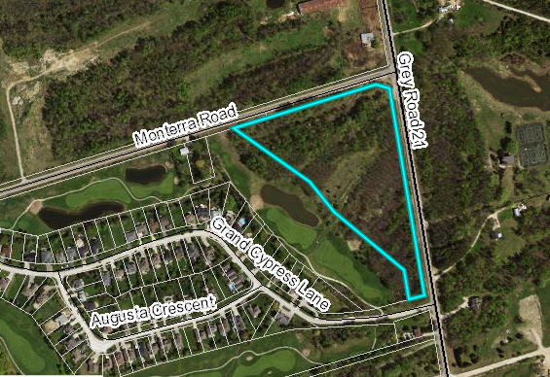

The proposed development also requires an amendment to the Town of The Blue Mountains Zoning By-law.

Pre-submission consultation between the proponent, the Town and the County identified the submission requirements for the proposed plan of subdivision. The following reports have been submitted with the subdivision application;

1. Planning Justification Report,
2. Stormwater Management Report,
3. Functional Servicing Report,
4. Traffic Brief, and
5. Revised Draft Plan.

Copies of all background reports and plans can be found at [this link.](https://www.grey.ca/planning-development/planning-applications)

In addition to the reports submitted, the proponent has also requested an exemption to the County Transportation Services Entrance Permit Procedure/Policy. This will be considered by the County Transportation Services Department as part of the review of the application.

### Map 2: Proposed Subdivision Plan

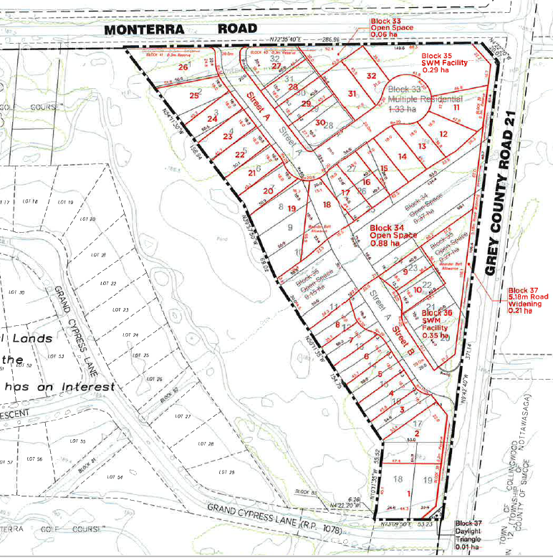

#### Analysis of Planning Issues

When rendering a land use planning decision, planning authorities must have regard to matters of Provincial Interest under the *Planning Act*, be consistent with the Provincial Policy Statement (PPS) 2014, and conform to any Provincial Plans or official plans that govern the subject lands. In this case, the Niagara Escarpment Plan, the County of Grey Official Plan and the Town of The Blue Mountains Official Plan all have jurisdiction over the subject property.

#### Provincial Policy and Legislation

Both the *Planning Act* and the PPS speak to the efficient use of land within settlement areas, where services are readily available. The proposed plan of subdivision is within a recreational settlement area that is serviced by municipal water and sewer services.

The subject lands are identified as Escarpment Recreation Area in the Niagara Escarpment Plan which contemplates development of this nature. The subject lands are outside of the Niagara Escarpment Development Control Area and therefore a development permit is not required from the Niagara Escarpment Commission (NEC). The proposed redline revisions will be circulated to the NEC for review and comment.

The supply of an adequate range of residential housing types is required in both Provincial documents. The provision of a suitable transportation network, both pedestrian and vehicular, is also noted in the Provincial legislation and policy. In this case, the proposed redline revisions are proposing a single housing type.

#### County Official Plan

The proposed plan of subdivision is designated as ‘Recreational Resort Area’ within the County Official Plan. Significant Woodlands are also identified on the subject lands. Within the Recreational Resort Area designation, the County Plan generally defers to the detailed land use policies and development standards of the municipal official plan or secondary plans.

Section 2.8 of the County Plan provides policies on Significant Woodlands that have been identified on the subject lands. The proposed redline revisions are within the existing development footprint of the draft approved plan and therefore an environmental impact study was not required to be submitted with the redline revision application.

Section 5.3 of the County Plan provides a similar servicing hierarchy to that found in the PPS, which has been noted above. Elsewhere in section 5 of the Plan are policies which govern roads and transportation.

### Town of The Blue Mountains Official Plan

The Town Official Plan designates the subject lands ‘Residential Recreational Area’. The purpose of the Residential Recreation Area designation is to ‘recognize areas within the Town where there is a mix of seasonal and permanent residential and recreational uses and recognize areas where some residential uses are located to support and provide access to resort and recreational amenities’.

A detailed analysis of Provincial, County, and Town policy has not been offered at this stage; however, following the public and agency review processes, a comprehensive planning analysis and final recommendations will be provided.

## Legal and Legislated Requirements

The application will be processed in accordance with the Planning Act.

## Financial and Resource Implications

There are no anticipated financial, staffing or legal considerations associated with the proposed redline revisions, beyond those normally encountered in processing the application. The County has collected the requisite fee for this application.

## Relevant Consultation

Internal: Planning Staff

External: Town of The Blue Mountains, required agencies under the Planning Act, and the public.

### Appendices and Attachments

*None*