**WE’VE RECEIVED A PLAN OF SUBDIVISION APPLICATION AND**

**WE WANT YOUR INPUT**

The County of Grey and the Town of The Blue Mountains want your feedback on a new development proposal.

#### Why did I get this notice?

You received this meeting notice as you live or own property within 120 metres of the proposed development location. You may have also already received a notice from the Town of The Blue Mountains on some additional development applications related to this proposed development.

#### Description of the Proposed Development

The County and the Town are seeking input on development applications (referred to as the Home Farm Development) to consider allowing for a 277 unit residential Plan of Subdivision on the subject lands shown below. The proposed development would consist of 85 single detached units, 60 semi-detached units, and 132 townhouse units. The Plan of Subdivision application has been submitted to the County, while the applicant has also applied for corresponding Official Plan and Zoning By-law Amendments from the Town of The Blue Mountains to permit the proposed development on the lands shown below.

#### Location of the Proposed Development

The subject lands are located in the Town of The Blue Mountains. The legal description of the property is Part of Lot 20, Concession 2, in the geographic Township of Collingwood, now in the Town of The Blue Mountains. See key map below.

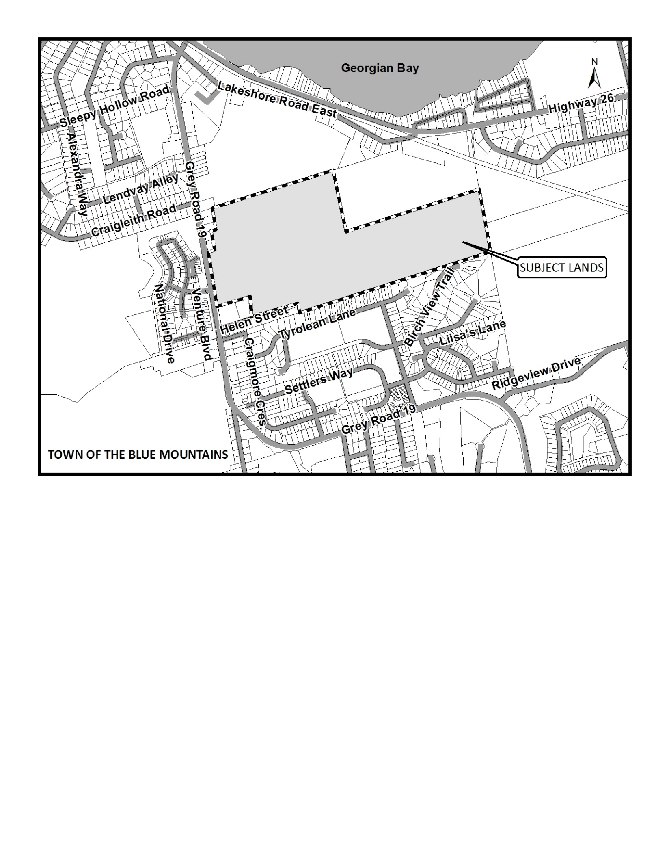

#### Location and Timing of the Public Meeting

At this point a public meeting has not been scheduled yet. When a public meeting is scheduled a notice will be circulated by the Town of The Blue Mountains, in accordance with the Regulations under the *Planning Act.*

#### What can I expect at the future Public Meeting?

The public meeting is an opportunity for members of the public to learn more about the proposed development. Attendees have the opportunity to hear a brief presentation about the development, ask questions, and/or make statements either in favour of, or in opposition to the development. At the meeting members of the public will also hear a summary of any comments received about the proposed development prior to the public meeting.

The public meeting will take place at a Council meeting and the Mayor or designated Chair will act as the moderator for the meeting. The moderator will keep the meeting in order and allow the applicant (and their development team), the public, and members of Council to speak and ask questions.

No decisions are made at this meeting. It is simply an opportunity to learn and provide feedback.

#### If I can’t attend the future Public Meeting, can I still participate?

Yes you can still participate. You can learn more about the proposed development by contacting the County or Town offices, or by reading the materials on the County or Town websites at the below links. You may also choose to submit comments via letter or email, after taking the time to learn about the proposed development. All of the contact information for both the Town and County has been provided below:

<http://www.grey.ca/services/planning-development/new-planning-applications/home-farm-development/>

<http://www.thebluemountains.ca/planning-development-proje.cfm#51>

| **County of Grey Contact Information:** | **Town of The Blue Mountains Contact Information:** |
| --- | --- |
| Scott Taylor  County of Grey Planning Department  595 9th Avenue East  Owen Sound, Ontario, N4K 3E3  Phone: 519-372-0219 ext. 1238  Email: [scott.taylor@grey.ca](mailto:scott.taylor@grey.ca) | Denise Whaley  Town of The Blue Mountains Planning and Development Department  32 Mill Street, P.O. Box 310  Thornbury, Ontario, N0H 2P0  Phone: 519-599-3131 ext. 262  Email: [dwhaley@thebluemountains.ca](mailto:dwhaley@thebluemountains.ca) |

#### What is being proposed through the applications?

This development requires three applications, a County of Grey Plan of Subdivision application, and Town of The Blue Mountains Official Plan and Zoning By-law Amendment applications. In order for the development to move forward, approvals are needed on all three of these applications. The County makes the decision on the Plan of Subdivision and the Official Plan Amendment* applications and the Town makes the decision on the Zoning By-law Amendment.

*Although the County would ultimately make the decision on an approval of the Official Plan Amendment application, that application is first submitted to the Town, and the County would not make an approval until the Town Council had already dealt with the matter. Through the Amendment application, the Town is being asked to ‘adopt’ the Amendment; and should it be adopted, the County is asked to ‘approve’ the Amendment. Should Town Council refuse the Official Plan Amendment it would not come to the County for any further approvals.

The proposed Plan of Subdivision would create two hundred and seventy-seven (277) new residential lots, along with associated blocks for stormwater management, parkland, and recreation facilities.

The effect of the proposed Official Plan Amendment is to re-designate a portion of the lands from the Institutional (I) and Recreational Residential Exception (RR-50) designations to a new Recreational Residential Exception (RR-xx) and Public Open Space (P). The Hazard Lands designation is also proposed to be refined. The RR-xx exception would limit development to a maximum number of 277 residential units, within single detached, semi-detached and townhouse dwellings, would permit a private neighbourhood recreation centre, and would establish parameters for the exchange of lands.

The effect of the proposed Zoning By-law Amendment is to re-zone the subject lands from the Deferred Development (DD) zone and Hazard (H) Zone to a combination of Residential Second Density Exception (R2-xx), Residential Third Density Exception (R3-xx), Residential Forth Density Exception (R4-xx), Residential Sixth Density Exception (R6-xx), Public Open Space (OS1) , Private Open Space (OS2), Private Recreational (PREC), and Hazard (H) zones. The various Residential Exception zones would establish specific building types permitted in each zone, the required setbacks, lot coverage, and building height specific to this property. The zones would also be subject to a Holding -h symbol that would restrict development until the Holding symbol is removed, which will require Site Plan Approval and the execution of a Site Plan Agreement.

The applications have been deemed complete, under the *Planning Act*, which means that it is now time to receive public feedback on the proposals. In deeming the applications complete, the County and the Town have enough information to seek public input on the development. No decisions have been made on the applications, and no decisions will be made until the public process has been completed.

#### Why this future Public Meeting is being held and what are your rights?

Within Ontario the planning and development process is an open and transparent process, where opinions from all individuals and groups are welcomed. By law a municipality must hold a public meeting, and this meeting is just one of your chances to learn about the development proposal and offer your opinions. Under the legislation governing this development, which is sections 34, 22 and 51 of the *Planning Act*, you have the following rights:

1. Any persons may attend the public meeting and/or make written or verbal representation either in support of or in opposition to the proposed Plan of Subdivision, Official Plan Amendment, or Zoning By-law Amendment.
2. If a person or public body does not make oral submissions at a public meeting or make written submissions to the Town of The Blue Mountains before the Official Plan and Zoning By-law Amendments are adopted or approved, or to the County of Grey before the Official Plan Amendment or Plan of Subdivision are approved, the person or public body is not entitled to appeal the decisions of the Town of The Blue Mountains or the County of Grey to the Ontario Municipal Board.
3. If a person or public body does not make oral submission at a public meeting, or make written submissions to the Town of The Blue Mountains before the Official Plan or Zoning By-law Amendments are adopted or approved, or to the County of Grey before the Official Plan Amendment and Plan of Subdivision is approved, the person or public body may not be added as a party to the hearing of an appeal before the Ontario Municipal Board unless, in the opinion of the Board, there are reasonable grounds to do so.
4. If you wish to be notified of the decision of the Town of The Blue Mountains in respect to the approval of the Official Plan and Zoning By-law Amendments, or the County of Grey in respect to the passing of the Official Plan Amendment and Plan of Subdivision, you must make a written request to the Town or the County, at the addresses noted on the previous page. Please note the Home Farm Development Zoning By-law Amendment or Official Plan Amendment file number 33 when directing correspondence to the Town. The County Plan of Subdivision file number is 42T-2015-03.

If you have any questions please do not hesitate to contact County or Town staff, who would be happy to answer any questions on the matter.

Dated at Owen Sound this 20th day of August, 2015