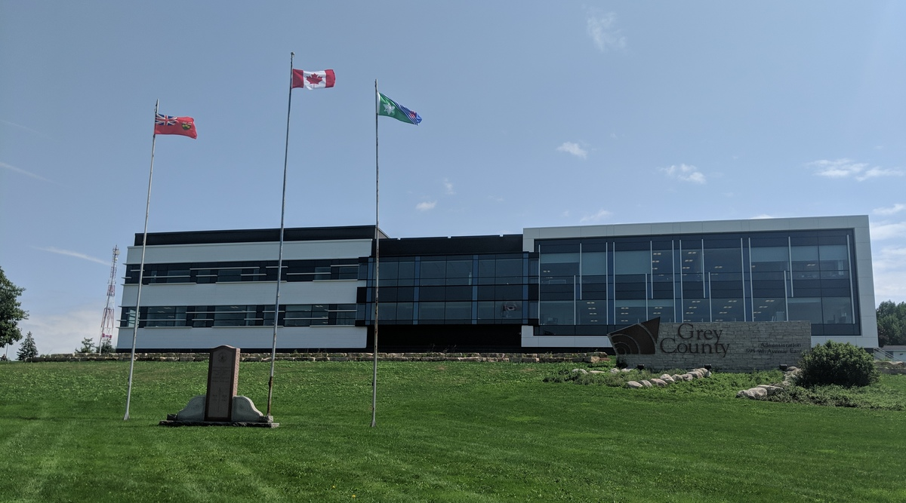



**2019 Budget Summary**

Contents

Executive Summary 3

Key 2019 Budget Proposals 4

2019 Operating and Capital Budget –Net Levy Requirements 5

2019 Budget 6

Budget Background 7

Building the Budget 7

Function Responsibilities 8

**HIGHLIGHTS** Corporate Services 9

**HIGHLIGHTS** Planning and Community Development 10

**HIGHLIGHTS** Social Services 11

**HIGHLIGHTS** Transportation and Public Safety 12

Our People 14

How Your Tax Dollars Work For You 15

2019 Budget Analysis (Net Dollars) by Standing Committee and Function 16

2019 Estimated Tax Impact 21

Additional 2019 Budget Information and Details – Contact Us: 22

# Executive Summary

Grey County delivers a wide range of important services. From maintaining roads to helping people at risk, the services we provide positively impact residents, visitors and businesses each and every day.

The 2019 budget contains operating and capital expenses of $155M. After operating and capital revenues, reserves and capital financing are calculated, $57M needs to be raised through taxes to maintain and enhance existing services.

The 2019 budget includes a net increase of $1,763,595 to support existing service levels. This increase is to be funded as follows:

* **1.75% tax rate increase of $983,848**
* **New assessment growth of $779,747**

# Key 2019 Budget Proposals

The 2019 budget has been developed to maintain current programs, enhance service levels and support important projects, as directed by Council. Some of the investments include:

* Resources to help manage land acquisition and emergency management planning
* Funding to undertake a corporate wellness program
* Continued upgrades to computer network infrastructure and saving for future needs
* Funding to undertake a Climate Change Action Plan to identify actions to mitigate and help increase resilience to the effects of climate change
* Trails structure replacements on the CP Rail Trail
* Funding allocated towards Community Improvement Plans (CIPs) for member municipalities to accelerate local economic development incentives.
* Capital funding to undertake start-up renovations and building lifecycle upgrades for the newly acquired Regional Training Centre
* Tourism marketing Grey County and destination development
* Update of Grey Roots gallery and the creation of a new “Voices of Grey” and “Honeybee” exhibits
* Expanding child care services for families
* Capital retrofit and expansion funds for Journey Together and EarlyON programs
* Creating more affordable housing and improving and preserving the quality of social housing
* Long-term care service management consulting support
* Continued funding for Community Paramedicine program
* Increasing spending on road construction, resurfacing and minor capital projects

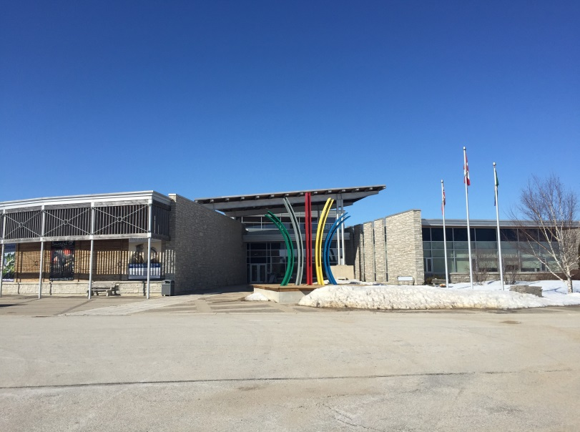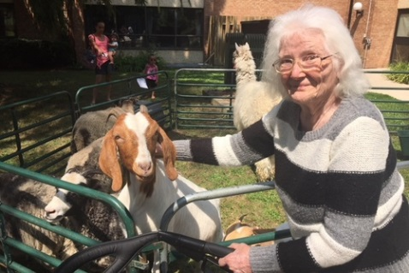 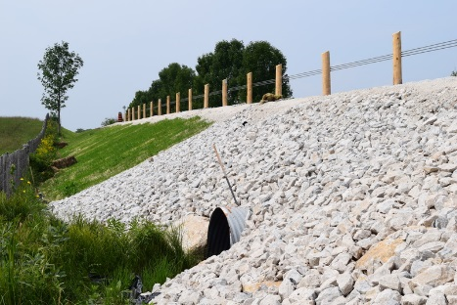

# 2019 Operating and Capital Budget –Net Levy Requirements

| **Function** | **2018**  **Net Levy** | **2019**  **Net Levy** | **Increase / (Decrease**) | **%**  **Change** |
| --- | --- | --- | --- | --- |
| Corporate Services | $9,597,780 | $9,953,781 | $356,001 |  |
| Planning & Community Development | $4,452,904 | $4,688,501 | $235,597 |  |
| Social Services | $17,188,479 | $17,009,653 | ($178,826) |  |
| Transportation and Public Safety | $24,218,202 | $25,569,025 | $1,350,823 |  |
| **Funding Required** | **$55,457,365** | **$57,220,960** | **$1,763,595** | **3.18%** |
|  |  |  |  |  |
| New Assessment Growth | $779,747 |  | ($779,747) |  |
| **Additional Funding to be Raised from Taxation**  **Net Levy Increase** | **$56,237,112** | **$57,220,960** | **$983,848** | **1.75%** |

The additional property tax revenue from new construction, often referred to as assessment growth, is incorporated into the 2019 budget based on the Municipal Property Assessment Corporation’s (MPAC) roll edition of assessment values.

For 2019, a 1% levy increase equals approximately $562,371.

# 2019 Budget



# Budget Background

Grey County delivers a wide range of services and programs. As a Consolidated Municipal Service Manager, we are mandated to deliver many important social and community health services.

**Service and Programs**

* 316 long-term care beds
* 997 units of safe and affordable housing across the county
* Paramedic Services responding to more than 24,000 annual calls
* Delivering income support and employment assistance
* Helping families access affordable child care
* Maintaining over 877km of roads and more than 192 bridges and structures over 3 metres

It is Grey County’s responsibility to deliver these and other programs and services as required by regulations and our agreements with funding partners. The annual budget determines how resources are directed towards services for the year.

Grey County is committed to the coordinated delivery of responsive and cost-effective services that strengthen the economic, social, environmental, and cultural well-being of the diverse communities it serves.

# Building the Budget

Each department meets with the Chief Administrative Officer and the Director of Corporate Services to review the departmental revenues, expenditures, net levy requirements and any service level or staffing enhancements. The Senior Management Team then further reviews and discusses these proposed budget plans.

Once these reviews are complete, the corporate budget overview and background is provided to County Council to inform councillors of the overall 2019 funding requirements recommended by staff.

Council discusses the proposed budget by function at a special budget workshop. Here council can ask questions, provide further direction to staff or approve the budget.

# Function Responsibilities

Grey County uses functions to discuss business and reports. Each function focuses on specific areas of municipal service.

| Corporate Services | Planning and Community Development |
| --- | --- |
| * Budget, assessment and taxation * Asset management * General legislation and by-laws * Provincial Offences Administration (courts) * Risk management and emergency management * Human Resources * Records Management * Information Technology * Accessibility * Legal Services | * Planning matters (official plans, subdivision and condominium plans, site plans) * Forest and Trail Management * Economic Development and Tourism * Business Enterprise Centre * Regional Skills Training, Trades & Innovation Centre * Heritage (Grey Roots) * Agriculture |
| Social Services | Transportation and Public Safety |
| * Ontario Works * Children’s Services * Long-term care (Lee Manor, Rockwood Terrace and Grey Gables) * Affordable housing, non-profit housing and homelessness prevention * Community and social support programs | * Engineering, maintenance and construction of roads, bridges and culverts * Winter maintenance of roads * Paramedic services * Community paramedicine program * Public access defibrillation |

# **HIGHLIGHTS** Corporate Services

* Net function requirement (operating and capital) of **$9,953,781** compared to $9,597,780 in 2018, an increase of $356,001
* Resources to help with land acquisition and emergency management planning
* Funding to develop corporate asset management policies, an asset management strategy and long term financial planning
* Establishing an internal Legal Services and Provincial Offences Prosecution functions.
* Funding for future Health Care Capital Initiatives
* Upgrading the County’s Information Technology network infrastructure and planning and saving for future refreshes
* The 5th installment of $200K of $2M in support to Georgian College for the Marine Emergency Duties (MED) Training and Research Centre.
* Funding to undertake a service review of the Human Resources Department
* Increased Provincial Offences revenue
* Administration building exterior and balcony deck painting, and replacement of outside balcony stair handrails
* Allocation from the Ontario Cannabis Legalization Fund for any future costs related to the legalization of cannabis.

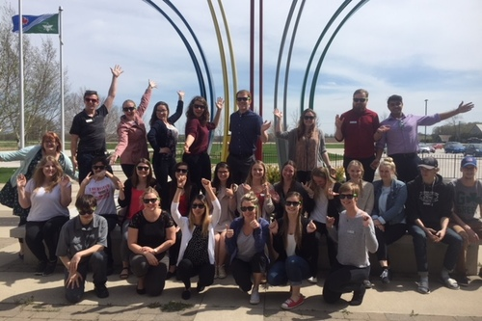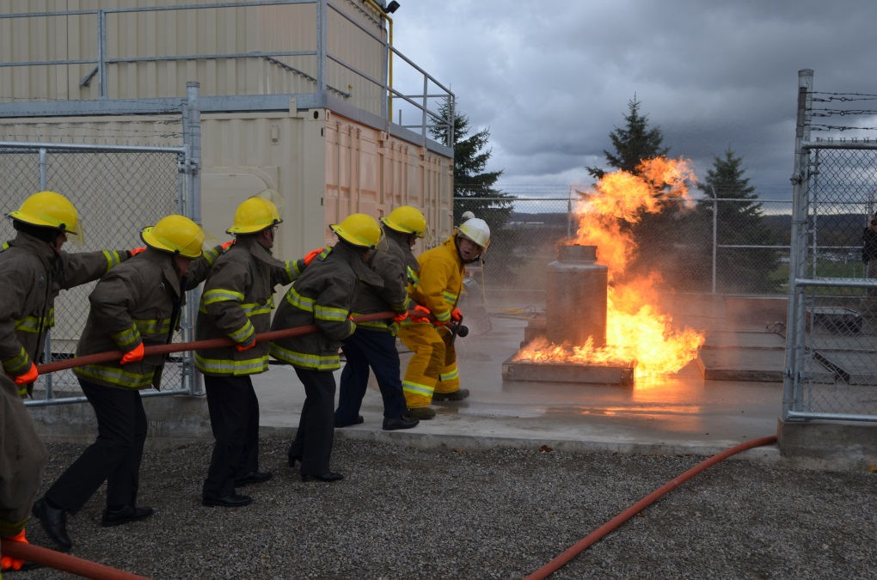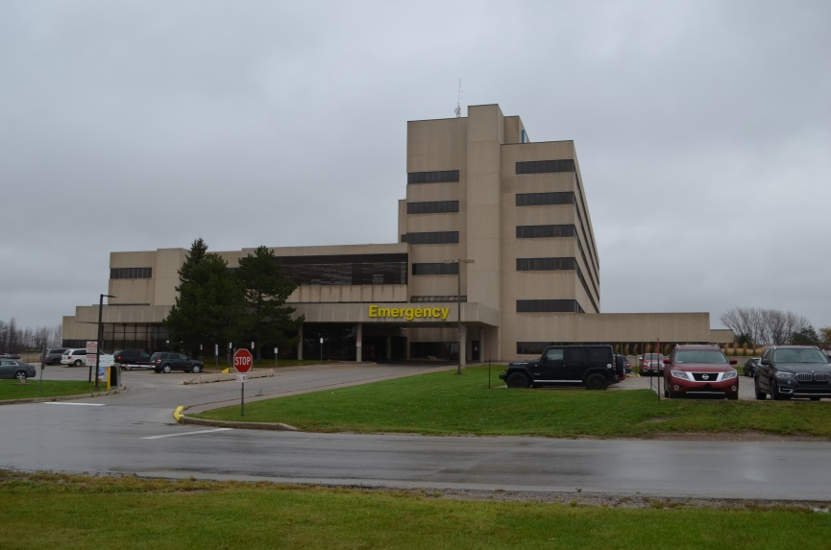

# **HIGHLIGHTS** Planning and Community Development

* Net function requirement (operating and capital) of **$4,688,501** compared to $4,452,904 in 2018, an increase of **$235,597**
* Resources for a contract Planner position to assist with development applications and various other projects
* Completion of the Forest Management Plan
* Completion of the Recreation Trails Master Plan for County Forests and County CP Rail Trail
* Resources to undertake a Climate Change Action Plan to identify actions to mitigate and help increase resilience to the effects of climate change
* Replace Culverts 5 and 7 on CP Rail Trail, and perform design and technical work on Culvert/Bridge 80, all in accordance with the Bridge and Culvert Assessment Report
* 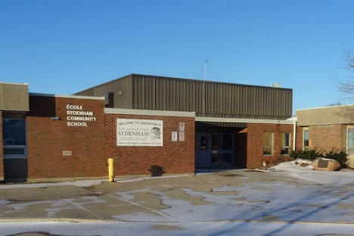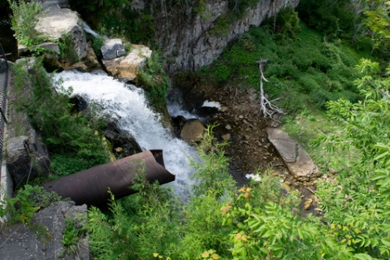Community Improvement Plan funding to provide incentives to support priority development such as affordable housing and to increase investment-ready properties, implemented in partnership with local municipalities
* Undertake start-up renovations and building upgrades for newly acquired Regional Training Centre
* Finalize the Grey County Cycling & Trails Master Plan
* Resources to undertake a Tourism Research and Data Analysis project
* Update the Tourism website – visitgrey.ca
* Construction of a new “Voices of Grey” and “Honeybee” exhibit in the Grey County Gallery
* Development of a Moreston Site Plan to guide the future growth of the living history site
* Develop a Marketing Plan and a Fundraising Plan to guide construction and acquisition of heritage buildings in Moreston
* Construction of a Grey County Cenotaph celebrating the 31st Regiment and the 147th and 248th Battalions in Moreston
* Developing a Membership Engagement plan
* Grey Roots’ roof replacement, theatre upgrade and building automation equipment update

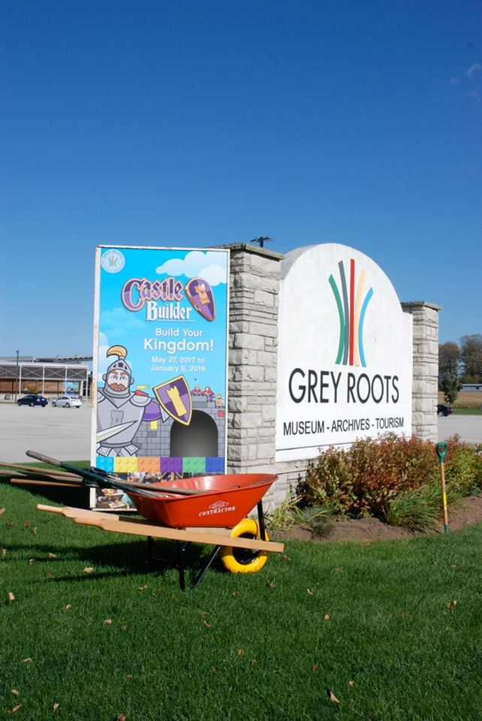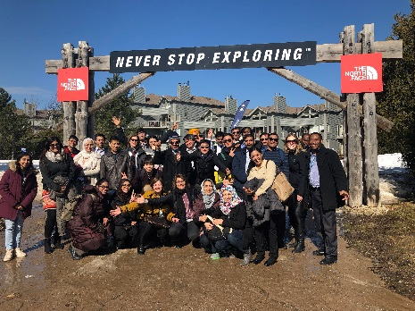

# **HIGHLIGHTS** Social Services

* Net function requirement (operating and capital) of **$17,009,653** compared to $17,188,479 in 2018, a decrease of (**$178,826)**
* 2019 Ontario Works budget based on an average caseload of 1,335 and a 1.5% mandated social assistance benefit allowance increase
* An increase of one FTE for an additional Administrative staff position in the Children’s Services department
* Child care resources to address legislative requirements, child care demand and to support the Ministry’s priority of increasing child care and EarlyON accessibility for families
* Continuing with partnership capital work involving two CBCP EarlyON projects, seven school-based child care/EarlyON projects and a Journey Together EarlyON project
* Funding to undertake a service review of the Ontario Works and Child Care Department
* Landscaping and fencing replacement at the EarlyON Child and Family Centre in Hanover
* Long Term Care quality improvement initiatives and working towards CARF (Commission on Accreditation of Rehabilitation Facilities) Accreditation
* Updating electronic health records and menu and financial management systems to improve reporting abilities and reflect sustainable and best practices in Long Term Care
* Capital projects to support the needs of the individual Homes; replacement of section of flat roof at Grey Gables, development of new outdoor area at Lee Manor, and replacement of building mechanical components and updating of resident bathing area at Rockwood Terrace
* Using provincial and federal funding to increase the supply of affordable housing and to improve and preserve our social housing units
* Manage and upgrade 109 additional units of housing in Meaford to increase overall stock to 997 units of community housing in Grey County

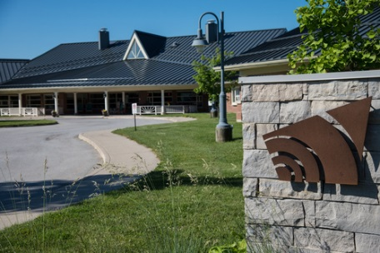

# **HIGHLIGHTS** Transportation and Public Safety

* Net function requirement (operating and capital) of **$25,569,025** compared to $24,218,202 in 2018, an increase of **$1,350,823**
* Budgeting a 1.5% funding increase from the Ministry of Health and Long-Term Care for Paramedic Services operations
* Opening of the new paramedic base in Chatsworth will improve response time to the Chatsworth and surrounding areas which traditionally have been serviced by the Owen Sound and Markdale bases
* Implementing a single person first response/patient navigator unit to improve emergency coverage, reduce response times and to support the coordination of the most appropriate health care resources, improve access to existing community and primary care services and reduce non-essential emergency visits for frequent callers of 911
* Ongoing funding from the South West LHIN for the community paramedic program provides home visits with expanded scope of care, remote home monitoring, community clinics and referrals five days per week with discussions to increase funding to provide coverage seven days per week and to expand the program to other areas across Grey County
* Adding a generator to the Owen Sound base will provide backup power to run essential systems during an outage and keep the base operational
* Funding for mandated post-traumatic stress disorder (PTSD) prevention and mental wellness program for paramedics
* Using Municipal511 and Responder511 to allow municipalities across the region to use a common platform to create and manage road-related information for the use of the public, County and local municipalities and allows incident command to draw details of the scene on a map for all emergency services to utilize
* Leveraging $1.249K in Ontario Community Infrastructure Funding for road rehabilitation
* Utilizing assessment growth to complete additional construction, resurfacing and minor capital projects in 2019
* Ongoing review of the operations of facilities in Patrol D (Dundalk and Flesherton) to develop a future investment plan
* Storm water sewer and culvert inspections as part of asset management strategy
* Replacing work management software
* Replacing single-axle five-ton trucks with tandem roll-off trucks to improve utilization and provide increased versatility to fleet
* Funding additional bridge designs and land acquisitions

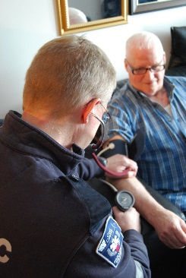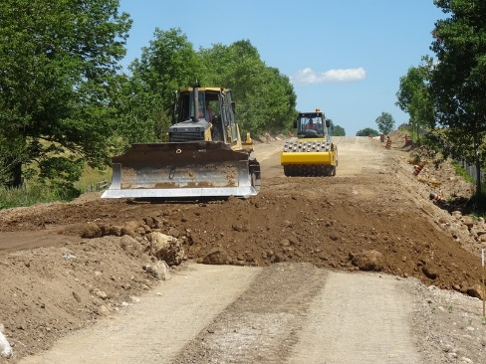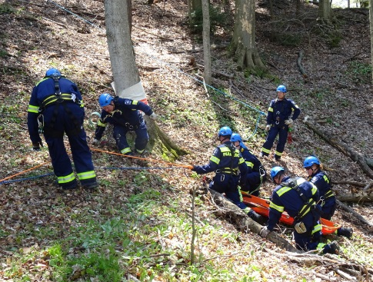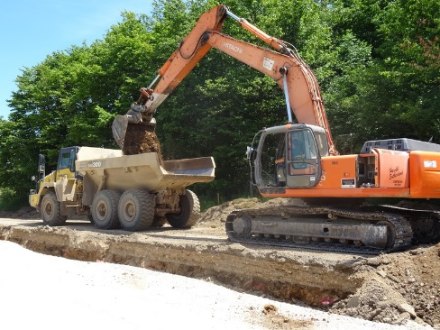

# Our People

896 full and part-time employees deliver Grey County services. The workforce is made up of 77% unionized employees and 23% non-union employees. Unionized staff is represented by nine separate bargaining units as outlined in the table.

The collective bargaining process in 2019 will involve ongoing negotiating with two employee groups and commencing the bargaining with three other groups of the collective agreements listed here.

For 2019, the Non-Union Employee Group’s annual wage increase of 1.65% has been calculated using an annual wage calculation formula. This formula uses five data sources to calculate an annual wage adjustment.

**Breakdown of unionized staff**

| **Employee Group** | **# of Employees** | **Contract End Date** |
| --- | --- | --- |
| ONA Registered Nurses  (3 – LTC Homes) | 28 | March 31, 2018 |
| OPSEU  Lee Manor | 194 | December 31, 2019 |
| UNIFOR  Rockwood Terrace | 132 | January 31, 2020 |
| OPSEU  Social Services | 45 | December 31, 2019 |
| OPSEU  Grey Gables | 98 | December 31, 2017 |
| OPSEU  Paramedic Services | 117 | December 31, 2017 |
| CUPE  Transportation Services | 79 | May 31, 2021 |

# How Your Tax Dollars Work For You

|  |  |  |  |  |  |  |  |
| --- | --- | --- | --- | --- | --- | --- | --- |
| **Support Per Function** | **Total Gross Expenditures**  **($000s)** | **Fed/Prov Grant Funding ($000s)** | **Reserve Funding ($000,s)** | **Other Funding ($000s)** | **Net Levy ($000s)** | **Portion of County Levy** | **Per $100,000**  **Residential**  **Assessment Value\*\*** |
| Corporate Services | 13,605 | (64) | (1,287) | (4,425) | 7,829 | 13.7% | $48.89 |
| Planning | 995 | - | (170) | (88) | 737 | 1.3% | $4.60 |
| Heritage, Economic Development, Agriculture, Forestry, Tourism and Trails | 7,476 | (401) | (2,391) | (732) | 3,962 | 6.9% | $24.68 |
| Health Care and Education Funding | 2,169 | - | (44) | - | 2,125 | 3.7% | $13.27 |
| Social Services  (Ontario Works & Child Care) | 34,024 | (29,437) | (734) | (352) | 3,501 | 6.1% | $21.87 |
| Affordable Housing | 15,650 | (3,020) | (1,139) | (4,253) | 7,199 | 12.6% | $45.20 |
| Long Term Care | 33,317 | (17,173) | (2,337) | (7,537) | 6,270 | 11.0% | $39.16 |
| Paramedic Services | 15,049 | (7,598) | (780) | (20) | 6,651 | 11.6% | $41.53 |
| Transportation Services | 32,387 | (1,250) | (11,608) | (611) | 18,918 | 33.1% | $118.14 |
| **Total** | **154,642** | **(58,943)** | **(20,460)** | **(18,018)** | **57,221** | **100.0%** | **$357.34** |
| *All numbers are rounded  **Estimate at this time. Final tax rate will not be finalized until annual tax policy items are endorsed by County Council.  Other funding includes application fees, donations, long-term care resident fees, housing tenant rent, admissions, sponsorship etc. | | | | | | | |

# 2019 Budget Analysis (Net Dollars) by Function

|  |  |  |  |  |  |  |  |
| --- | --- | --- | --- | --- | --- | --- | --- |
|  | **2018** | | | **2019** | | |  |
|  | **BUDGETS** | | | **BUDGETS** | | | **Change** |
|  | **Operating** | **Capital** | **Combined** | **Operating** | **Capital** | **Combined** | **19 Levy to 18** |
| **Corporate Services Budget** | **Net Operating Budget** | **Net Capital Budget** | **Net Tax Levy** | **Net Operating Budget** | **Net Capital Budget** | **Net Tax Levy** | **Increase / (Decrease)** |
| Council | $643,978 | - | $643,978 | $752,400 | - | $752,400 | $108,422 |
| Administration Department | $4,221,665 | $102,200 | $4,323,865 | $4,539,200 | $156,850 | $4,696,050 | $372,185 |
| Workers Comp & Wkly Indem. Self Ins. | - | - | - | - | - | - | - |
| Information Systems | - | - | - | - | - | - | - |
| Assessment (MPAC) | $1,816,600 | - | $1,816,600 | $1,849,200 | - | $1,849,200 | $32,600 |
| Provincial Offences | ($385,435) | - | ($385,435) | ($418,900) | - | ($418,900) | ($33,465) |
| Property | $378,112 | $786,839 | $1,164,951 | $298,492 | $788,439 | $1,086,931 | ($78,020) |
| Taxation and Other | ($63,300) | - | ($63,300) | ($136,900) | - | ($136,900) | ($73,600) |
| **Sub Total** | **$6,611,620** | **$889,039** | **$7,500,659** | **$6,883,492** | **$945,289** | **$7,828,781** | **$328,122** |
| Health Unit | $1,625,421 | - | $1,625,421 | $1,647,700 | - | $1,647,700 | $22,279 |
| Hospital Grants & Health Care Funding | $271,700 | - | $271,700 | $277,300 | - | $277,300 | $5,600 |
| Georgian College - MED Training Centre | $200,000 | - | $200,000 | $200,000 | - | $200,000 | - |
| **Sub Total** | **$2,097,121** | **-** | **$2,097,121** | **$2,125,000** | **-** | **$2,125,000** | **$27,879** |
| **Total Corporate Services** | **$8,708,741** | **$889,039** | **$9,597,780** | **$9,008,492** | **$945,289** | **$9,953,781** | **$356,001** |

|  |  |  |  |  |  |  |  |
| --- | --- | --- | --- | --- | --- | --- | --- |
|  | **2018** | | | **2019** | | | **Change**  **19 Levy to 18** |
|  | **BUDGETS** | | | **BUDGETS** | | |
|  | **Operating** | **Capital** | **Combined** | **Operating** | **Capital** | **Combined** |
| **PLANNING & COMMUNITY DEVELOPMENT** | **Net Operating Budget** | **Net Capital Budget** | **Net Tax Levy** | **Net Operating Budget** | **Net Capital Budget** | **Net Tax Levy** | **Increase / (Decrease)** |
| **ECONOMIC DEVELOPMENT, AGRICULTURE, FORESTRY, TOURISM, TRAILS & GREY ROOTS** |  |  |  |  |  |  |  |
| Econ. Dev't/Ag/Forestry/Tour./Trails | $1,518,776 | $102,500 | $1,621,276 | $1,599,626 | $177,960 | $1,777,586 | $156,410 |
| Grey Roots | $1,821,820 | $317,300 | $2,139,120 | $1,865,405 | $308,700 | $2,174,105 | $34,985 |
| **Sub Total** | **$3,340,596** | **$419,800** | **$3,760,396** | **$3,465,031** | **$486,660** | **$3,951,691** | **$191,395** |
|  |  |  |  |  |  |  |  |
| **PLANNING & DEVELOPMENT** |  |  |  |  |  |  |  |
| Planning & Studies | $688,508 | $4,000 | $692,508 | $719,160 | $17,650 | $736,810 | $44,302 |
| **Sub Total** | **$688,508** | **$4,000** | **$692,508** | **$716,160** | **$17,650** | **$736,810** | **$44,302** |
| **Total Planning & Community Development** | **$4,029,104** | **$423,800** | **$4,452,904** | **$4,184,191** | **$504,310** | **$4,688,501** | **$235,597** |

|  |  |  |  |  |  |  |  |
| --- | --- | --- | --- | --- | --- | --- | --- |
|  | **2018** | | | **2019** | | |  |
|  | **BUDGETS** | | | **BUDGETS** | | | **Change** |
|  | **Operating** | **Capital** | **Combined** | **Operating** | **Capital** | **Combined** | **19 Levy to 18** |
| **SOCIAL SERVICES, HOUSING & LONG-TERM CARE** | **Net Operating Budget** | **Net Capital Budget** | **Net Tax Levy** | **Net Operating Budget** | **Net Capital Budget** | **Net Tax Levy** | **Increase / (Decrease)** |
| **Ontario Works** |  |  |  |  |  |  |  |
| Social Assistance | $87,250 | - | $87,250 | $95,550 | - | $95,550 | $8,300 |
| Community Homelessness Prevention Initiative | - | - | - | - | - | - | - |
| Ontario Works Administration | $1,301,712 | - | $1,301,712 | $1,330,174 | - | $1,330,174 | $28,462 |
| Ontario Works | $556,842 | - | $556,842 | $569,913 | - | $569,913 | $13,071 |
| Child Care | $1,164,296 | $44,000 | $1,208,296 | $1,156,216 | $44,350 | $1,200,566 | ($7,730) |
| County Social Initiatives | $298,310 | - | $298,310 | $305,310 | - | $305,310 | $7,000 |
| **Sub Total** | **$3,408,410** | **$44,000** | **$3,452,410** | **$3,457,163** | **$44,350** | **$3,501,513** | **$49,103** |
| **Housing** |  |  |  |  |  |  |  |
| Housing | $6,123,819 | **$1,342,604** | **$7,466,423** | **$5,868,994** | **$1,369,500** | **$7,238,494** | **($227,929)** |
| **Sub Total** | **$6,123,819** | **$1,342,604** | **$7,466,423** | **$5,868,994** | **$1,369,500** | **$7238,494** | **($227,929)** |
| **Long Term Care** |  |  |  |  |  |  |  |
| Grey Gables | **$1,112,683** | **$281,892** | **$1,394,575** | **$1,112,683** | **$281,892** | **$1,394,575** | - |
| Lee Manor | **$1,705,882** | **$219,109** | **$1,924,991** | **$1,705,882** | **$219,109** | **$1,924,991** | **-** |
| Rockwood Terrace | **$1,269,061** | **$320,009** | **$1,589,070** | **$1,299,061** | **$290,009** | **$1,589,070** | **-** |
| Long Term Care Redevelopment |  | **$1,361,010** | **$1,361,010** |  | **$1,361,010** | **$1,361,010** | **-** |
| **Sub Total** | **$4,087,626** | **$2,182,020** | **$6,269,646** | **$4,117,626** | **$2,152,020** | **$6,269,646** | **-** |
| **Total Social Services, Housing and Long Term Care** | **$13,619,855** | **$3,568,624** | **$17,188,479** | **$13,443,783** | **$3,565,870** | **$17,009,653** | **($178,826)** |

|  |  |  |  |  |  |  |  |
| --- | --- | --- | --- | --- | --- | --- | --- |
|  | **2018** | | | **2019** | | |  |
|  | **BUDGETS** | | | **BUDGETS** | | | **Change** |
|  | **Operating** | **Capital** | **Combined** | **Operating** | **Capital** | **Combined** | **19 Levy to 18** |
| **TRANSPORTATION & PUBLIC SAFETY** | **Net Operating Budget** | **Net Capital Budget** | **Net Tax Levy** | **Net Operating Budget** | **Net Capital Budget** | **Net Tax Levy** | **Increase / (Decrease)** |
| **Paramedic Services** |  |  |  |  |  |  |  |
| Paramedic Services | $6,324,413 | $78,593 | $6,403,006 | $6,556,923 | $93,996 | $6,650,919 | $247,913 |
| **Sub Total** | **$6,324,413** | **$78,593** | **$6,403,006** | **$6,556,923** | **$93,996** | **$6,650,919** | **$247,913** |
| **Transportation Services** |  |  |  |  |  |  |  |
| Ordinary Maintenance/Winter Control | $7,700,600 | - | $7,700,600 | $7,862,700 | - | $7,862,700 | $162,100 |
| Construction, Resurfacing and Minor Capital | - | $7,564,196 | $7,564,196 | - | $8,357,006 | $8,357,006 | $792,810 |
| Supervision & Overhead | $1,764,900 | - | $1,764,900 | $1,820,400 | - | $1,820,400 | $55,500 |
| Housing & Depots | $329,500 | $300,000 | $629,500 | $321,000 | $306,000 | $627,000 | ($2,500) |
| Equipment - Operations & Cap | - | - | - | - | - | - | - |
| Asset Management, Studies and Engineering | $144,000 | - | $144,000 | $238,000 | - | $238,000 | $94,000 |
| Quarry | $12,000 | - | $12,000 | $13,000 | - | $13,000 | $1,000 |
| **Sub Total** | **$9,951,000** | **$7,864,196** | **$17,815,196** | **$10,255,100** | **$8,663,006** | **$18,918,106** | **$1,102,910** |
| **Total Transportation & Public Safety** | **$16,275,413** | **$7,942,789** | **$24,218,202** | **$16,812,023** | **$8,757,002** | **$25,569,025** | **$1,350,823** |

|  |  |  |  |  |  |  |  |
| --- | --- | --- | --- | --- | --- | --- | --- |
|  | **2018** | | | **2019** | | |  |
|  | **BUDGETS** | | | **BUDGETS** | | | **Change** |
|  | **Operating** | **Capital** | **Combined** | **Operating** | **Capital** | **Combined** | **19 Levy to 18** |
|  | **Net Operating Budget** | **Net Capital Budget** | **Net Tax Levy** | **Net Operating Budget** | **Net Capital Budget** | **Net Tax Levy** | **Increase / (Decrease)** |
| **TOTAL TO RAISE FROM TAXATION** | **$42,633,113** | **$12,824,252** | **$55,457,365** | **$43,448,489** | **$13,772,471** | **$57,220,960** | **$1,763,595** |
| Calculation of Tax Rate Increase  for 2019  1% = $562,371 |  |  | 2019 Levy Increase Over 2018 Approved Budget | | | $1,763,595 |  |
| 2018 New Growth  $779,747 | Less: New Assessment Growth | | | ($779,747) |
| 2019 Budgetary Levy Increase Net of New Growth | | | $983,848 |
|  | **2019 Budgetary Increase over the 2018 Approved Budget** | | | **1.75%** |

The 2018 New Growth of $779,747 is based on the Municipal Property Assessment Corporation’s (MPAC) roll edition of assessment values.

# 2019 Estimated Tax Impact

|  |  |  |
| --- | --- | --- |
| **APPROXIMATE TAX INCREASE PER RESIDENTIAL  PROPERTY ASSESSMENT\*** | | |
| **County Tax Rate Increase** | | |
| % | $ | per $100,000 |
| **1.75** | **983,848** | **$6.14** |
| **Note:** Actual taxation impacts do not parallel assessment change because of Ontario's variable tax rate system. Tax rates vary by property class and assessment based on tax ratios, which affect the distribution of the tax levy across classes. The numbers noted are for illustration purposes only. | | |

**2019 Average Increase per Household**



# Additional 2019 Budget Information and Details – Contact Us:

**County of Grey**

595 9th Avenue East,

Owen Sound, Ontario N4K 3E3

519-376-2205

[Grey.ca](http://www.Grey.ca)

**Office of the Warden and CAO,**

Selwyn Hicks - [warden@grey.ca](mailto:warden@grey.ca)

Kim Wingrove, Chief Administrative Officer - [cao@grey.ca](mailto:cao@grey.ca)

**Finance Department**

Kevin Weppler, Director of Corporate Services - [kevin.weppler@grey.ca](mailto:kevin.weppler@grey.ca)