NOTICE OF COMPLETE APPLICATIONS
What: The County and Township are seeking input on development applications within 120 metres of your property that would consider allowing a 101 unit plan of subdivision and zoning by-law amendment.
Site: Part Lot 227, Concession 2, SWTSR, Township of Southgate (former geographic Township of Proton)
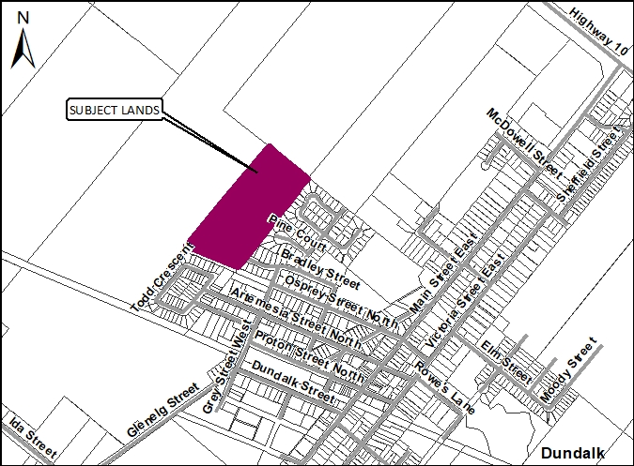

Public Meeting? At this point a public meeting has not been scheduled. Once a public meeting has been scheduled you will be notified of the date, time, and location.
Request for information: For information on the County Plan of Subdivision visit:
www.grey.ca/planning-development/planning-applications

For information on the Township Zoning By-law Amendment process visit:
https://southgate.civicweb.net/filepro/documents/96456

How do I submit comments? You may choose to submit comments via letter or email after taking the time to learn about the proposed development. See contact information below:
County of Grey Contact Information: | Township of Southgate Contact Information:
Stephanie Lacey-Avon (Planner)  County of Grey Planning Department  595 9th Avenue East  Owen Sound, Ontario, N4K 3E3  Phone: 519-372-0219 ext. 1296  Email: Stephanie.Lacey-Avon@grey.ca | Clinton Stredwick ( Planner)  Township of Southgate  185667 Grey County Road 9, RR 1  Dundalk, Ontario, N0C 1B0  Phone: 519-923-2110 ext. 228  Email: cstredwick@southgate.ca

What is being proposed through these applications?
Below is a map showing the proposed plan of subdivision. A full version of this map is available on the County website, or at the County office in Owen Sound, or Municipal office in Dundalk.
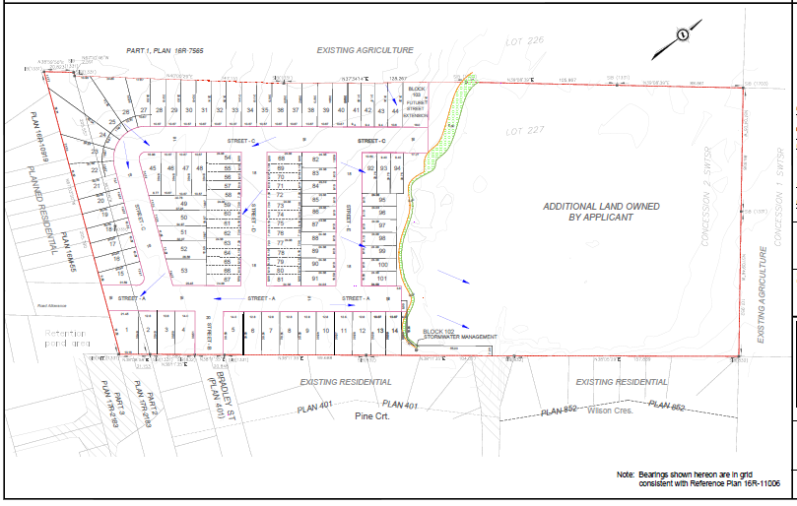

What is being proposed through the applications?
The purpose and effect of the plan of subdivision is to create one hundred and one (101) unit plan of subdivision, consisting of seventy-three (73) single-detached lots, and townhouse blocks of four or five units (28).
The purpose of the zoning by-law amendment is to amend the Township of Southgate Comprehensive Zoning By-law No. 6-2009 as amended to rezone the subject lands to implement the 101 unit plan of subdivision. The effect of the zoning by-law amendment is to change the zone symbol on the subject lands from A2 Restricted Agriculture to Residential type one exception ( R1-XXX) and Residential type three exception (R3-XXX).The Environmental Protection (EP) boundary may be adjusted based on the submitted studies and the recommendations of the GRCA. The provisions for the R1 and R3 zones proposed to be modified include: lot frontage, lot area, lot coverage, front yard setback, interior side yard, exterior side yard, and rear yard.
What can I expect at the Public Meeting?
The public meeting is an opportunity for members of the public to learn more about the proposed development. Attendees have the opportunity to hear a brief presentation about the development, ask questions, and/or make statements either in favour of, or in opposition to the development.
The public meeting will take place at a Council meeting and the moderator will keep the meeting in order and allow the applicant (or their development team), the public, and Council to speak and ask questions. No decisions are made at this meeting, it is an opportunity to learn and provide feedback.
Why is this Public Meeting being held and what are your rights?
Within Ontario, the planning and development process is open and transparent, where opinions from all individuals and groups are welcomed. By law municipalities must hold a public meeting. This meeting is one of your chances to learn about the development proposal and offer your opinions. Under the legislation governing this development process, which is sections 34, and 22 of the Planning Act, you have the following rights:
- Any persons may attend the public meeting and/or make written or verbal representation either in support of or in opposition to the proposed plan of subdivision or zoning by-law amendment.
- If a person or public body would otherwise have an ability to appeal the decision of County of Grey in reference to the plan of subdivision, or the Township of Southgate in reference to the zoning by-law amendment to the Local Planning Appeal Tribunal, but the person or public body does not make oral submissions at a public meeting or make written submissions to Grey County and the Township of Southgate before the subdivision and zoning by-law are passed, the person or public body is not entitled to appeal the decision.
- If a person or public body does not make oral submissions at a public meeting or make written submissions to County of Grey in reference to the plan of subdivision, or Southgate in reference to the zoning by-law amendment before the subdivision and zoning are passed, the person or public body may not be added as a party to the hearing of an appeal before the Local Planning Appeal Tribunal unless, in the opinion of the Tribunal, there are reasonable grounds to do so.
- If you wish to be notified of the decision of the Township of Southgate in respect to the approval of the zoning by-law amendment, or the County of Grey in respect to the approval or refusal of the plan of subdivision, you must make a written request to the Township or the County, at the addresses noted on the previous page. Please note the project name ‘White Rose Park’ for the zoning by-law amendment when directing correspondence to the Township, and/or the County plan of subdivision file #42T-2018-08.
If you have any questions please do not hesitate to contact County or Township staff, who would be happy to answer any questions on these applications, or the planning process.

Dated this 19th day of September, 2018, in Owen Sound.

