NOTICE OF A PUBLIC MEETING AND COMPLETE APPLICATIONS
WE WANT TO HEAR FROM YOU
WHAT: The County and Town are seeking input on development applications within 120 metres of your property that would consider allowing a 12 lot plan of subdivision and a zoning by-law amendment.
SITE: Block 46, Registered Plan 16M-20 Town of The Blue Mountains
Geographic Township of Collingwood

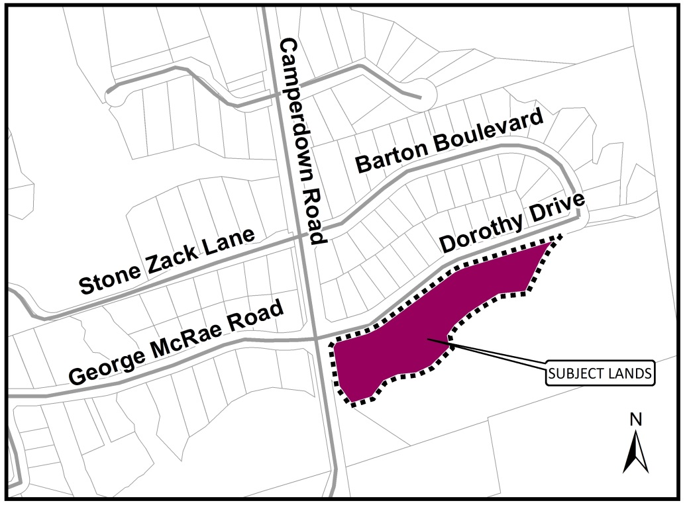

Location of Public Meeting – Town of The Blue Mountains Council Chambers, 32 Mill Street, Thornbury, Ontario
Timing of Public Meeting – Wednesday, November 15th, 2017 at 5:00 p.m.
How can I contribute my opinion?
Any person or agency may attend the Public Meeting and/or make verbal or written comments regarding this proposal.

Request for information:
For information on the County Plan of Subdivision visit:
www.grey.ca/planning-development/planning-applications

For all supporting studies and reports for the proposed Town of The Blue Mountains Zoning By-law Amendment please contact the Town at the below address.
How do I submit comments?
Submit written comments or sign-up to be notified of a decision by mailing or contacting:

 | Scott Taylor (Grey County Planner)  County of Grey Planning Department  595 9th Avenue East  Owen Sound, ON, N4K 3E3 |  | Denise Whaley (Town Planner)  Town of The Blue Mountains  PO Box 310, 32 Mill Street  Thornbury, ON, N0H 2P0
 | scott.taylor@grey.ca |  | dwhaley@thebluemountains.ca
 | 519-372-0219 ext. 1238 |  | 519-599-3131 ext. 262

What is being proposed through the applications?
The purpose and effect of the plan of subdivision is to create twelve (12) new lots for detached residential dwellings.
The purpose of the zoning by-law amendment is rezone the lands to change the housing type allowed on the property from a maximum of 65 townhouses to single detached dwellings. The effect of the proposed zoning would be to change from Residential Sixth Density Exception (R6-172-h) with a holding symbol, to the Residential Third Density (R3) zone.

What can I expect at the Public Meeting?
The public meeting is an opportunity for members of the public to learn more about the proposed development. Attendees have the opportunity to hear a brief presentation about the development, ask questions, and/or make statements either in favour of, or in opposition to the development.
The public meeting will take place at a Council meeting and the moderator will keep the meeting in order and allow the applicant (and their development team), the public, and members of Council to speak and ask questions. No decisions are made at this meeting, it is simply an opportunity to learn and provide feedback.

Why is this Public Meeting being held and what are your rights?
Within Ontario the planning and development process is an open and transparent process, where opinions from all individuals and groups are welcomed. By law a municipality must hold a public meeting, and this meeting is just one of your chances to learn about the development proposal and offer your opinions. Under the legislation governing this development process, which is sections 51 and 34 of the Planning Act, you have the following rights:
- Any persons may attend the public meeting and/or make written or verbal representation either in support of or in opposition to the proposed plan of subdivision or zoning by-law amendment.
- If a person or public body does not make oral submissions at a public meeting or make written submissions to the Town of The Blue Mountains before the zoning by-law amendment is approved or refused, or to the County of Grey before the plan of subdivision is approved or refused, the person or public body is not entitled to appeal the decisions of the Town of The Blue Mountains or the County of Grey to the Ontario Municipal Board.
- If a person or public body does not make oral submissions at a public meeting or make written submissions to the Town of The Blue Mountains before the zoning by-law amendment is approved or refused, or to the County of Grey before the plan of subdivision is approved or refused, the person or public body may not be added as a party to the hearing of an appeal before the Ontario Municipal Board unless, in the opinion of the Board, there are reasonable grounds to do so.
- If you wish to be notified of the decision by the Town of The Blue Mountains in respect to the approval or refusal of the zoning by-law amendment, or the County of Grey in respect to the approval or refusal of the plan of subdivision, you must make a written request to the Town or the County, at the addresses noted on the previous page. Please note the project name “Peaks Meadows” for the zoning by-law amendment when directing correspondence to the Town, and/or the County plan of subdivision file # 42T-2016-06.
- If you have any questions please do not hesitate to contact County or Town staff, who would be happy to answer any questions on the matter.
Dated at Owen Sound this 18th day of October, 2017.

