Grey County Logo Committee Report

# Report PDR-CW-15-17

**To**: Warden Barfoot and Members of Grey County Council

**From**: Randy Scherzer, Director of Planning

**Meeting Date:** February 23, 2017

**Subject: CP Rail Trail Relocation – Miller Paving Limited and City of Owen Sound**

**Status**: Recommendation adopted by Committee as presented per Resolution CW36-17; Endorsed by County Council March 9, 2017 per Resolution CC11-17;

## Recommendation

1. **That a by-law be prepared authorizing the Warden and Clerk to enter into an agreement with the City of Owen Sound and Miller Paving Limited as attached to Report PDR-CW-15-17 regarding a long-term lease for a portion of the CP Rail Trail located between 20th Street East and 23rd Street East; and**
2. **That the lease agreement include a provision that Miller Paving Limited bear responsibility for all costs associated with re-routing and reinstating the Trail.**

## Background

The County received a request from the City of Owen Sound and Miller Paving Limited (Miller) in 2012 to lease a portion of the CP Rail Trail located between 20th Street East and 23rd Street East in the City of Owen Sound. The reason for the request is that Miller is interested in purchasing lands from the City of Owen Sound to expand their current operations which are located west of the subject lands. The CP Rail Trail separates the lands currently owned by Miller and the lands that Miller would like to purchase from the City (see Map 1 below).

Confidential Report CCR-PCD-22-12 was presented to Committee in March 2012 regarding this matter. Staff were directed to negotiate a long-term lease of the portion of the CP Rail Trail with the City and Miller with the requirement that Miller construct a new trail section that would reroute the trail around the lands to be purchased by Miller from the City of Owen Sound. This would ensure that a continuous trail exists for trail users.

### Map 1 – Location of the Subject Lands

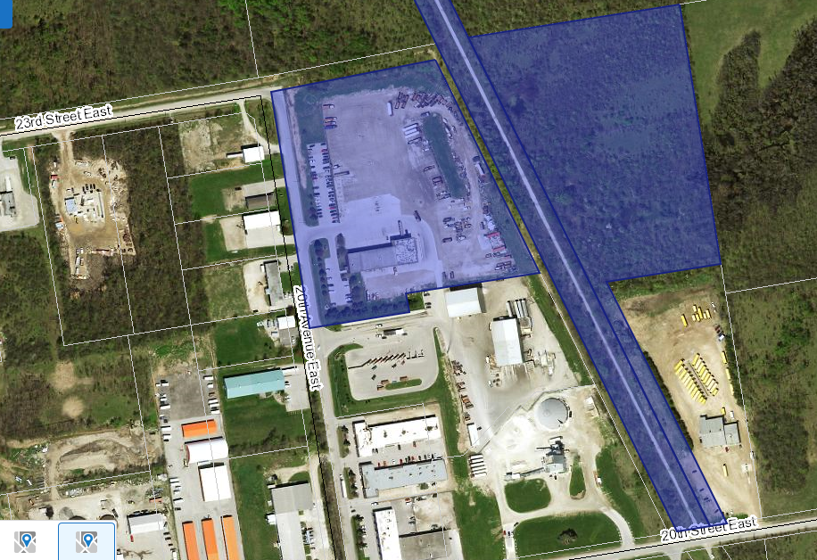

In addition to the requirement to reroute the trail, the following are other matters that are addressed in the attached agreement or will be addressed as part of the Site Plan:

* fencing will be erected around the new site to separate the trail use from the proposed Miller operation;
* stormwater will be handled to not negatively affect the trail (this will be addressed as part of the Site Plan requirements);
* permanent buildings or structures are prohibited on the leased lands;
* a termination clause has been included that is acceptable to all parties (see Section 21 of the Agreement);
* a requirement that Miller Group reinstate the trail in its original location at the end of the lease arrangement.

A lease agreement has been prepared which is attached to this report. This agreement has been prepared by the County/City solicitor and has been reviewed under the County’s agreement review process. The agreement addresses all the above noted matters as previously directed by Council.

A surveyed reference plan has been prepared which forms part of the agreement. Below is an image of the reference plan and a link to the reference plan is included in the attachments section below. In terms of the parts identified on the reference plan, the intent would be as follows:

* Miller would purchase Part 1 from the City of Owen Sound
* Part 6 and Part 7 (current CP Rail trail section) would be leased by Miller from the County
* Part 3 would remain under the ownership of the City
* Parts 2, 4 and 5 would be leased by the County from the City and Miller would reroute the trail on these parts at Miller’s expense

### Map 2 – Excerpt of Reference Plan 16R-10752

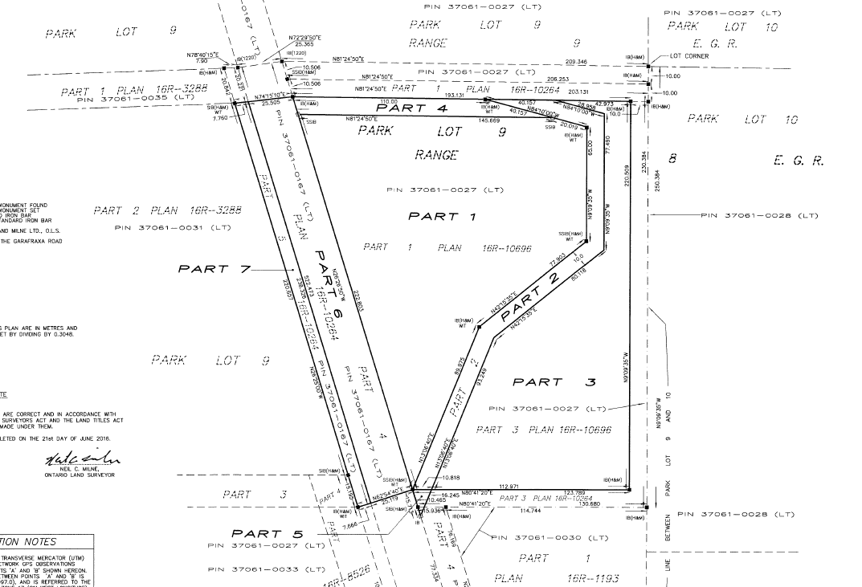

Miller was required to prepare an environmental impact study (EIS) to support the proposed expansion to their operations. The EIS concluded that a portion of the City owned land (Part 1) and the portion of the CP Rail Trail (Part 6) can be used for the proposed use with no anticipated negative impacts to the natural features or functions. The EIS also concluded that the trail can be re-routed on the lands identified as Parts 2, 4 and 5 without any negative impacts to the nature features. The EIS recommended mitigation measures including that some lands not be developed (Part 3), that buffers are established around certain features, and that remedial action work be completed including the relocation of a pond from the Part 1 lands to the Part 3 lands. The Site Plan will address the mitigation measures identified in the EIS.

## Financial/Staffing/Legal/Information Technology Considerations

All costs associated with the lease agreement, including legal costs as well as costs to reroute the trail will be at the expense of Miller. There are no costs associated with this request other than staff time spent negotiating the agreement and reviewing the agreement. There will be staff time required to ensure that the re-routed trail meets risk management standards as well as the needs of the trail users.

## Link to Strategic Goals/Priorities

This report links to Goal 3 of the Corporate Strategic Plan – Deliver Excellence and Service, specifically as it relates to collaboration with member municipalities.

## Attachments

[**Miller City County CP Rail Trail Lease Agreement**](https://docs.grey.ca/share/s/MMPXNxefQ1OG4xFkNsbqKw)

[**Reference Plan 16R-10752**](https://docs.grey.ca/share/s/GWoT6GShSpSfq4XbUgywMQ)

Respectfully submitted by,

Randy Scherzer  
Director of Planning