NOTICE OF COMPLETE APPLICATION - WE WANT TO HEAR FROM YOU
WHAT: The County and Township are seeking input on development applications within 120 metres of your property that would consider allowing an 8 lot single detached residential plan of subdivision.
SITE: 343622 Church Sideroad East, Part of Lot 27, Concession 3, RP 16R5146 – Parts 1 to 9, Geographic Township of Sarawak, Township of Georgian Bluffs

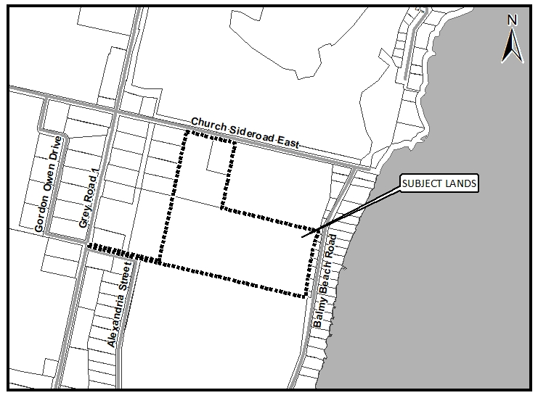

LOCATION OF PUBLIC MEETING? To be determined, a notice will be sent out at a later date.
TIMING OF PUBLIC MEETING? To be determined, a notice will be sent out at a later date.

How can I contribute my opinion?
Any person or agency may attend the Public Meeting and/or make verbal or written comments regarding this proposal.

How do I submit comments?
Submit written comments or sign-up to be notified of a decision by mailing or contacting:

Randy Scherzer (Grey County Planner)
County of Grey Planning Department
595 9th Avenue East
Owen Sound, ON, N4K 3E3

randy.scherzer@grey.ca
519-519-372-0219 ext. 1237

Request for information
For information on the Subdivision Application visit www.grey.ca/planning-development/planning-applications

For all supporting studies and reports for the proposed Georgian Bluffs Official Plan Amendment and Zoning By-law Amendment contact:

Jenn Burnett (Township Planner)
Township of Georgian Bluffs
177964 Grey Road 18, R.R. #3
Owen Sound, ON, N4K 5N5

jburnett@georgianbluffs.on.ca
519-376-2729 ext. 242

What is being proposed through the applications?
The purpose and effect of the Plan of Subdivision Application is proposing to create a total of 8 single detached residential lots and a future development block. The proposal is to service these lots with municipal water and private septic systems.
The purpose of the Georgian Bluffs Official Plan Amendment application is to change the land use designation of the subject lands from ‘Future Development’ to ‘Residential’ to facilitate the development of an 8 lot Plan of Subdivision. The remainder of the South Part of Lot 27 will continue to be designated ‘Future Development’. The purpose and effect of the proposed zoning by-law amendment application is to rezone the lands from Planned Development ‘PD’ to General Residential ‘R1’ to facilitate an 8 lot Plan of Subdivision. No other relief to the provisions of the Township of Georgian Bluffs Comprehensive Zoning By-law 6-2003 has been requested.

What can I expect at the Public Meeting?
The public meeting is an opportunity for members of the public to learn more about the proposed development. Attendees have the opportunity to hear a brief presentation about the development, ask questions, and/or make statements either in favour of, or in opposition to the development.
The public meeting will take place at a Council meeting and the moderator will keep the meeting in order and allow the applicant (and their development team), the public, and members of Council to speak and ask questions. No decisions are made at this meeting, it is simply an opportunity to learn and provide feedback.

Why is this Public Meeting being held and what are your rights?
Within Ontario the planning and development process is an open and transparent process, where opinions from all individuals and groups are welcomed. By law a municipality must hold a public meeting, and this meeting is just one of your chances to learn about the development proposal and offer your opinions. Under the legislation governing this development process, which is sections 17, 22, 34, and 51 of the Planning Act, you have the following rights:
- Any persons may attend the public meeting and/or make written or verbal representation either in support of or in opposition to the proposed Official Plan Amendment, Zoning By-law Amendment, or Plan of Subdivision.
- If a person or public body does not make oral submissions at a public meeting or make written submissions to the Township of Georgian Bluffs before the zoning by-law is approved or refused, or to the County of Grey before the Township Official Plan Amendment is approved or refused (following adoption by the Township) or the Plan of Subdivision is approved or refused, the person or public body is not entitled to appeal the decisions of the Township of Georgian Bluffs or the County of Grey to the Ontario Municipal Board.
- If a person or public body does not make oral submissions at a public meeting or make written submissions to the Township of Georgian Bluffs before the zoning by-law is approved or refused, or to the County of Grey before the Township Official Plan Amendment or the Plan of Subdivision is approved or refused, the person or public body may not be added as a party to the hearing of an appeal before the Ontario Municipal Board unless, in the opinion of the Board, there are reasonable grounds to do so.
- If you wish to be notified of the decision by the Township of Georgian Bluffs in respect to the approval or refusal of the Zoning By-law Amendment, or the County of Grey in respect to the approval or refusal of the Township Official Plan Amendment or the Plan of Subdivision, you must make a written request to the Township or the County, at the addresses noted on the previous page. Please note application Z-03-18 (for the Zoning By-law Amendment) and Georgian Bluffs Official Plan Amendment #7 when directing correspondence to the Township and Plan of Subdivision Application 42T-2017-05 when directing comments to the County.
- If you have any questions please do not hesitate to contact County or Township staff, who would be happy to answer any questions on the matter.
Dated at Owen Sound this 26th day of January, 2018.

