NOTICE OF COMPLETE APPLICATION - WE WANT TO HEAR FROM YOU
WHAT: The County and Town are seeking input on a plan of subdivision application within 120 metres of your property that would consider 34 single detached dwellings.
SITE: Part of Lot 26, Concession 6, Geographic Township of Collingwood, Town of The Blue Mountains

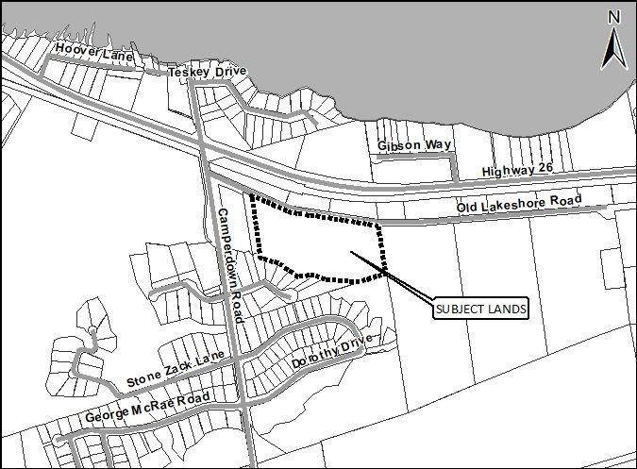

PUBLIC MEETING LOCATION? To be determined.
TIMING OF PUBLIC MEETING? Notice of Public Meeting will be circulated at a later date once the public meeting has been scheduled.

How can I contribute my opinion?
Any person or agency may attend the Public Meeting and/or make verbal or written comments regarding this proposal.

How do I submit comments?
Submit written comments or sign-up to be notified of a decision by mailing or contacting:

Randy Scherzer (Grey County Planner)
County of Grey Planning Department
595 9th Avenue East
Owen Sound, ON, N4K 3E3

randy.scherzer@grey.ca
519-519-372-0219 ext. 1237

Request for information
For information on the Subdivision Application visit www.grey.ca/planning-development/planning-applications

Denise Whaley (Town Planner)
Town of The Blue Mountains
PO Box 310 – 32 Mill Street
Thornbury, ON, N0H 2P0

planning@thebluemountains.ca
519-599-3131 ext. 262

What is being proposed through the applications?
The Plan of Subdivision Application is proposing to create a total of 34 single detached dwellings. A new private/condominium road would be constructed shown on the proposed plan as ‘Lane A’. A proposed trail block has also been shown along the frontage of the subject lands. An open space block has been proposed along the entire south end of the property. This new subdivision application replaces Condominium Application 42-CDM-2010-01 (Camperdown East 1) which has been withdrawn by the Applicant and the condominium file has been officially closed.

What can I expect at the Public Meeting?
The public meeting is an opportunity for members of the public to learn more about the proposed development. Attendees have the opportunity to hear a brief presentation about the development, ask questions, and/or make statements either in favour of, or in opposition to the development.
The public meeting will take place at a Council meeting and the moderator will keep the meeting in order and allow the applicant (and their development team), the public, and members of Council to speak and ask questions. No decisions are made at this meeting, it is simply an opportunity to learn and provide feedback.

Why is this Public Meeting being held and what are your rights?
Within Ontario the planning and development process is an open and transparent process, where opinions from all individuals and groups are welcomed. By law a municipality must hold a public meeting, and this meeting is just one of your chances to learn about the development proposal and offer your opinions. Under the legislation governing this development process, which is section 51 of the Planning Act, you have the following rights:
- Any persons may attend the public meeting and/or make written or verbal representation either in support of or in opposition to the proposed Plan of Subdivision.
- If a person or public body does not make oral submissions at a public meeting or make written submissions to the County of Grey before the Plan of Subdivision is approved or refused, the person or public body is not entitled to appeal the decision of the County of Grey to the Local Planning Appeal Tribunal.
- If a person or public body does not make oral submissions at a public meeting or make written submissions to the County of Grey before the Plan of Subdivision is approved or refused, the person or public body may not be added as a party to the hearing of an appeal before the Local Planning Appeal Tribunal unless, in the opinion of the Tribunal, there are reasonable grounds to do so.
- If you wish to be notified of the decision by the County of Grey in respect to the approval or refusal of the Plan of Subdivision, you must make a written request to the County, at the addresses noted on the previous page. Please note Plan of Subdivision Application 42T-2018-06 when directing comments to the County.
- If you have any questions please do not hesitate to contact County or Town staff, who would be happy to answer any questions on the matter.
Dated at Owen Sound this 3rd day of October, 2018.

