Grey County Logo Committee Report

# Report CAOR-TAC-12-17

**To**: Chair Gingras and Members of the Tourism Advisory Committee

**From**: Pat Hoy, Director of Transportation and

Bryan Plumstead, Manager of Tourism

**Meeting Date:** June 14, 2017

**Subject:** Great Lakes Waterfront Trail - Southern Georgian Bay

**Status**: Recommendation adopted by the Tourism Advisory Committee as presented per resolution TAC02-17; Endorsed by Committee of the Whole June 29, 2017; Endorsed by County Council July 13, 2017;

## Recommendation

1. **That Grey County formally advise the Waterfront Regeneration Trust that it wishes to participate in the extension of the Waterfront Trail through Grey County in the municipalities of the Township of Georgian Bluffs, City of Owen Sound, Municipality of Meaford and The Town of The Blue Mountains;**
2. **That Grey County advise the Waterfront Regeneration Trust that Grey County will pay the annual dues of $1,500 per year which includes the dues for the municipalities through which the trail network passes;**
3. **That Grey County work with the affected municipalities and the Waterfront Regeneration Trust to identify Waterfront Trail sign requirements, costs and potential funding partners. Any funding not secured through other sources for the entire trail signage would come from the Grey County transportation general reserve.**

### Great Lakes Waterfront Trail in Grey County

The Great Lakes Waterfront Trail (Waterfront Trail) is a signed route that connects 100+ communities and First Nations over its 2000 kilometre length from Quebec to Toronto to Sault Ste. Marie (Map attached following report.) It follows the St. Lawrence River to three of Canada’s Great Lakes (Ontario, Erie and Huron), the earth’s largest group of freshwater lakes and a Canadian icon. It connects 500 parks and natural areas including wetlands, beaches, forests, three UNESCO Biospheres, heritage sites and villages and many popular wine regions.

A workshop for the Great Lakes Waterfront Trail was held March 7, 2017 at Grey Roots and included staff from the City of Owen Sound, the Tom Thomson Trail, the Municipality of Meaford, the County of Simcoe, Blue Mountain Resorts, the Town of Collingwood, Regional Tourism Organization 7 and Grey County Tourism and Transportation. All present supported the implementation of the trail, and the group has continued to work to finalize the exact trail routing. Subsequent to the meeting, staff from Waterfront Regeneration Trust (WRT) followed up with Georgian Bluffs and The Blue Mountains, who could not attend, to inform them of this trail development.

Participation in the Waterfront Trail would not require the construction of any new trails. It uses existing local, county and provincial roads and trail routes which follow as close as reasonably possible to the shoreline. In some places, the trail goes right along the shore, in others it is a considerable distance back from the bay, traversing farmland, forest or the rocky terrain of the Niagara Escarpment. It will allow cyclists to enjoy the beauty of the region, as well as views and access to the Georgian Bay shoreline.

In Grey County, the Waterfront Trail will utilize Grey Roads 1, 12 and 15 in addition to other roads and trails, notably the Tom Thomson Trail and the Georgian Trail. The route would need to be consistently signed using the Waterfront Trail logo.

The current proposed draft of the trail route can be found [here](https://drive.google.com/open?id=1GKNC2PBo5GVVtdUONStYXFubxIw&usp=sharing)

The Waterfront Regeneration Trust staff and its Board are very excited about the extension of the Trail through Grey County, and wish to move forward quickly on implementation. The WRT has secured funding to provide the directional signage to our local communities, but the poles, hardware and installation costs would be borne by Grey County and the local municipalities. This has been the practice in all 68 other municipalities through which the Trail passes.

The WRT also requires a nominal annual fee from Grey County and the municipalities for participation in the Trail. If the County acts as the direct contact, the fee would be $1,500 annually. Note that if each municipality were to join individually the cost would be $2500. The WRT will provide the following types of services and assistance to the county and its member municipalities:

* Extending their mapping program to Grey County, producing PDF-style maps and adding the route to their Google-based map system;
* Developing and maintaining content for the Waterfront Trail website to promote the County and its communities, as well as to connect trail users to our own web resources;
* Extending the "State of the Trail" inventory to Grey County. This tool tracks planned, in-progress and completed capital projects across the Trail, and allows the WRT to present to the senior governments the level of investment and build a case for their investment;
* Producing and installing trail route markers and trailhead signs at major staging areas along the route;
* Launching the new Grey County portion of the Trail with a "Great Waterfront Trail Adventure" style event;
* Connections to external agencies and partners such as the Canadian Automobile Association, which is significantly increasing its promotion of cycle tourism.

## Background

The Great Lakes Waterfront Trail (Waterfront Trail) is a signed route that connects 100+ communities and First Nations over its 2000 kilometre length from Quebec to Toronto to Sault Ste. Marie (Map attached following report.) It follows the St. Lawrence River to three of Canada’s Great Lakes (Ontario, Erie and Huron), the earth’s largest group of freshwater lakes and a Canadian icon. It connects 500 parks and natural areas including wetlands, beaches, forests, three UNESCO Biospheres, heritage sites and villages and many popular wine regions.

The Waterfront Regeneration Trust, established as a Royal Commission in 1988, is a non-profit organization that has been coordinating the establishment of The Great Lakes Waterfront Trail. Its founding Chair (and still a member of the Board of Directors) is former Toronto mayor and federal cabinet minister David Crombie. <http://www.waterfronttrail.org/index.html>

### Expansion of the Great Lakes Waterfront Trail around Georgian Bay

The idea of a cycling route around Georgian Bay came from the Manitoulin Island Cycling Advocates (MICA) who established a volunteer steering committee to oversee a feasibility study for the route. The Study was conducted by Transportation options and the Resource Management Consulting Group in 2013/14. Over the course of the study, 65 representatives of municipalities, tourism organizations, health units and cycling clubs participated in workshops held in Little Current, Sudbury, Parry Sound, Gravenhurst, Midland, Collingwood, Owen Sound and Wiarton or were interviewed by telephone. Support for the Georgian Bay Cycling Route was strong with 58 letters of support for the concept received, including letters from Grey County, Township of Georgian Bluffs, City of Owen Sound, Municipality of Meaford and The Town of the Blue Mountains, and the Grey Bruce Health Unit. [Link to the Feasibility Study](https://www.waterfronttrail.org/images/Georgian_Bay_Cycling_Route/GBCyR_Implementation_Plan_FINAL.pdf)

In May 2014, the Waterfront Regeneration Trust (WRT) accepted an invitation from the Georgian Bay Cycling Route Steering Committee to lead the implementation of the Georgian Bay Cycling Route as part of the Great Lakes Waterfront Trail. In the interim, Grey County’s Cycling Advisory Committee has suggested route refinements and has been kept informed of the progress of the Waterfront Regeneration Trust in completing other routes with the intention of working on the Georgian Bay Route in 2017/18.

With funding from the Ministry of Tourism, Culture and Sport, the Waterfront Regeneration Trust is set to expand the Trail and its partnership of communities into Manitoulin, Bruce, Grey and Huron Counties by the fall of 2018. The initiative will add 650 km to the Great Lakes Waterfront Trail and connect the section in Northern Ontario from Sault Ste. Marie to Sudbury to the Southern Ontario section, which currently terminates in Grand Bend. Workshops were recently held in Owen Sound and Saugeen Shores to kick-off the trails expansion along the Lake Huron Shoreline and Southern Georgian Bay.

## Financial/Staffing/Legal/Information Technology Considerations

Staff recommend that Grey County be responsible for the annual fees payable to the WRT in the amount of $1,500 (or $300/partner). If each local municipality and the county pay individually the cost would be $2,500 (or $500/partner)

The WRT has secured funding for the signs themselves, but in all other municipalities along the route, the local municipalities have been responsible for supplying sign hardwareand installing the signs. WRT will be undertaking a sign audit to determine the specific number, type and locations for signs. While staff do not have a specific number of signs required, directional signs would be needed where the trail route turns, but on straight stretches of the route, the standard is approximately one sign every 2.5 kilometers. Existing sign posts may be used where that is appropriate and legal.

The waterfront trail route would cover approximately 95km on roads in Grey County and the member municipalities and another 30 kms along the Georgian Trail. An estimate of signs (both directions) every 2.5km plus corners would work out to about 250 signs. Grey could likely produce and install these for $80/sign. Actual costs would depend on how many signs could be mounted on existing posts. An outside estimate would be $20,000 and the likely cost would be less. They could be maintained at a lower unit cost than regulatory signage as they would not require the same standards for reflectivity. This signage could also qualify for 50% funding under RTO7’s Partnership Funding program, and Grey County could apply on behalf of all municipalities to simplify this. Any unsecured signage funding would come from the transportation general reserve.

## Link to Strategic Goals/Priorities

Joining the Great Lakes Waterfront Trail addresses the Grey County goal of supporting Healthy Connected Communities. The trail will supply residents and tourists with connections between attractions as well as an area for local recreation. This will also support Growing Grey’s Economy through enhanced tourism visitation and expenditures.

## Attachments and Background Information

Great Lakes Waterfront Trail Map

Respectfully submitted by,

Bryan Plumstead, Tourism Manager

Pat Hoy, Director of Transportation

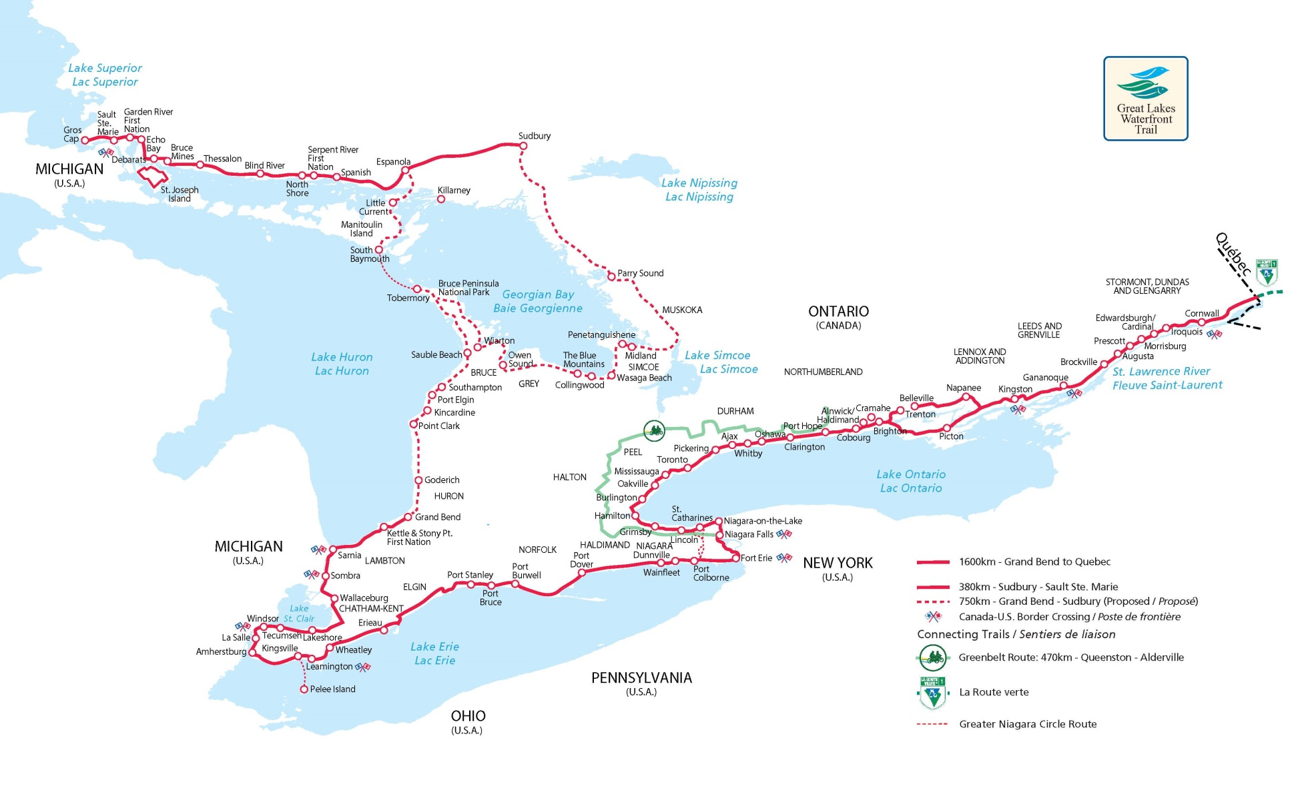

Great Lakes Waterfront Trail Sign

