REVISED - NOTICE OF A PUBLIC MEETING - WE WANT TO HEAR FROM YOU
WHAT: The County and Municipality are seeking input on development applications within 120 metres of your property that would revise the previously approved Draft Plan of Subdivision to reduce the size of the future commercial block along Sykes Street North (Highway 26) and reduce the size of the stormwater management block which results in an increase in the size of the adjacent future residential block. To implement these proposed changes to the subdivision, changes to the Official Plan and Zoning By-law are required. These changes affect only the northeast portion of the overall subject lands (generally north of Country Crescent).

SITE: 206080 Highway 26 (Sykes Street North) and legally described as Plan 309, Pt. Lot 1697 in the Municipality of Meaford (in the geographic former Town of Meaford) and shown on the key map below.

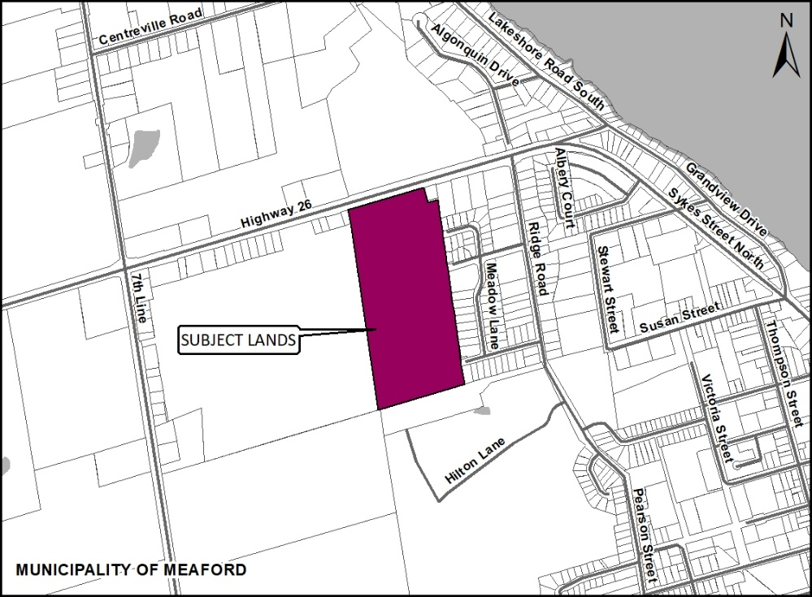
REVISED Timing of the Public Meeting: Monday May 2nd, 2022 at 5:00 P.M.
Please note that the former April 4th, 2022 meeting date has been cancelled and the new date for the meeting will be Monday May 2nd, 2022 at 5:00 P.M.
Meeting Location: In-person at Meaford Hall (12 Nelson Street East in the Opera House) OR the option to participate remotely via Zoom.
Meeting Information: Members of the public are encouraged to provide comments and questions on the application.
If a member of the public wishes to speak at the public meeting, they may do so either in-person at Meaford Hall or remotely via Zoom (phone/internet). Those wishing to speak at the public meeting in-person or remotely MUST register in advance with Development Services by noon on May 2nd, 2022 by contacting planning@meaford.ca or 519-538-1060 ext. 1120. An email with access information will be sent to those who register for remote participation.
If you do not wish to speak at the public meeting, we encourage you to watch the meeting live via the Municipality of Meaford’s YouTube channel at www.meaford.ca/youtube or provide your written comments to the County and Municipal contacts provided on below.

How do I submit comments?
Submit written comments or sign-up to be notified of a decision by mailing or contacting:

 | Scott Taylor (Grey County Planner) |  | Denise McCarl (Meaford Planner)
 | County of Grey  595 9th Avenue East  Owen Sound, ON, N4K 3E3 |  | Municipality of Meaford  21 Trowbridge Street West  Meaford, ON, N4L 1A1
 | scott.taylor@grey.ca |  | planning@meaford.ca
 | 519-372-0219 extension 1238 |  | 519-538-1060 extension 1120

How can I contribute my opinion?
Any person or agency may attend the Public Meeting and/or make verbal or written comments regarding this proposal.

Request for information
For information on the applications visit https://www.grey.ca/planning-development/planning-applications or https://www.meaford.ca/en/business-development/meaford-haven-revisions-opa-zbla.aspx
What is being proposed through the applications?

Background: In 2012 a subdivision commonly referred to as Meaford Haven received draft plan of subdivision approval subject to detailed conditions to be satisfied prior to final approval. Related site specific Official Plan and Zoning By-law Amendments were also approved at that time to provide the policy famework for future development. Since that time the subject lands are under new ownership.
Current Applications: New applications have been submitted to modify the subdivision plan and site specific Official Plan and Zoning By-law provisions as they apply to the northeast portion of the site.
Please note that the proposed changes affect only the northeast portion of the subject lands. There is no change proposed to the street pattern or environmental protection lands. All of the proposed changes are north of the existing stream (generally north of Country Crescent).
The new and revised applications include the following:
Redline Revision to Draft Plan of Subdivision (County file number 42T-2011-03)
The purpose and effect of the revision to the subdivison is to reduce the size of the future commercial block along Sykes Street North (Highway 26) and reduce the size of the stormwater management block, which results in an increase in the size of the adjacent future residential block.
To implement these proposed changes to the Draft Plan of Subdivision, Official Plan and Zoning By-law Amendments are required as described below.
Official Plan Amendment (Municipality of Meaford file number OPA 30)
To reduce the size of the “Urban Highway Commercial” designated area by redesignating a portion of the lands to “Urban Living Area” which is the same designation that applies to adjacent residential lands.
Zoning By-law Amendment (Municipailty of Meaford file number Z02-22)
To reduce the size of the “Highway Commercial – Exception” (C2-239-H5) Zone and to reduce the size of the “Open Space – Exception” (OS-200) Zone by rezoning a portion of the lands to “Multiple Residential – H5” (RM-H5) Zone which is the same zone that applies to the adjacent residential lands.
These changes recogize the fact that a medical facility is no longer required on the subject lands as one has already been developed just east of the subject lands. The applicant also indicates that the stormwater management block can be reduced and a stormwater management report has been submitted by the applicant to support the reduction of the Open Space zone.
Any future commercial or multi-residential development would require site plan approval at which time the detailed design for individual blocks would be assessed. The whole of the subdivision also remains subject to the conditions of the original Draft Plan of Subdivision.
This is an excerpt of the redlined Draft Plan of Subdivision provided by the applicant:
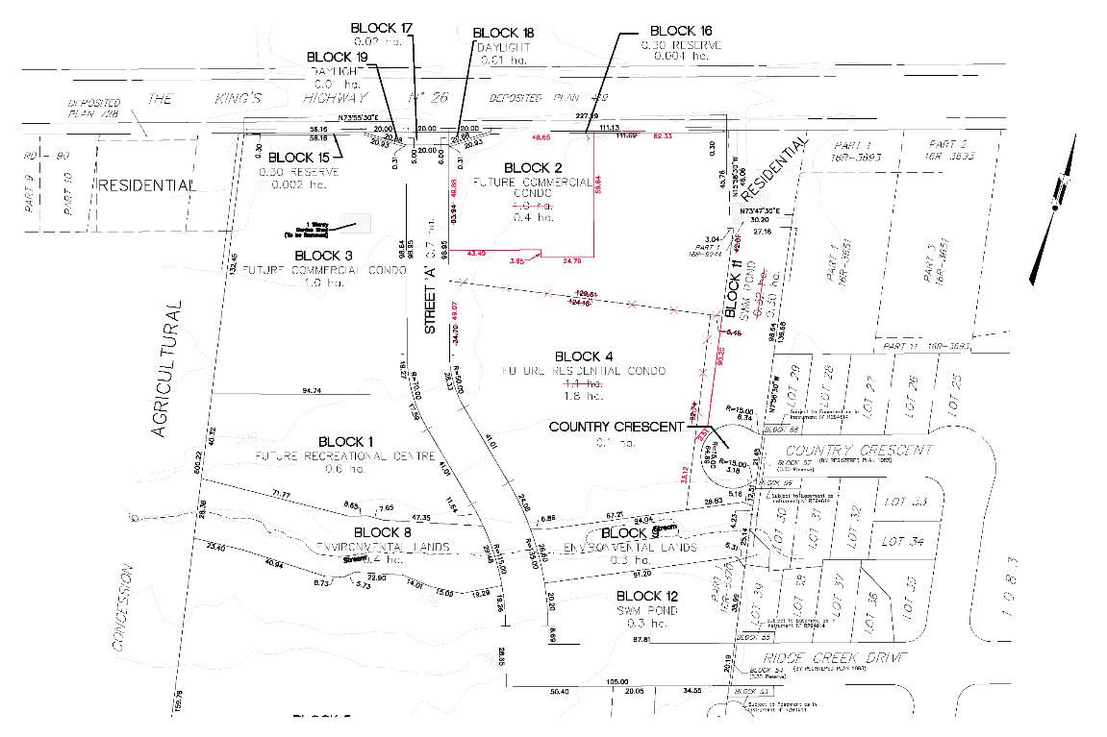

What can I expect at the Public Meeting?
The public meeting is an opportunity for members of the public to learn more about the proposed development. Attendees have the opportunity to hear a brief presentation about the development, ask questions, and/or make statements either in favour of, or in opposition to the development.
The public meeting will take place at a Council meeting and the moderator will keep the meeting in order and allow the applicant (and their development team), the public, and members of Council to speak and ask questions. No decisions are made at this meeting, it is simply an opportunity for you to learn and provide feedback.
Why is this Public Meeting being to be held and what are your rights?
Within Ontario the planning and development process is an open and transparent process, where opinions from all individuals and groups are welcomed. By law, a municipality must hold a public meeting, and this meeting is just one of your chances to learn about the development proposal and offer your opinions. Under the legislation governing this development process, which is sections 22, 34 and 51 of the Planning Act, you have the following rights:
- Any persons may attend the public meeting and/or make written or verbal representation either in support of or in opposition to the proposed official plan amendment, zoning by-law amendment or draft plan of subdivision.
- If a *person or public body would otherwise have an ability to appeal the decisions of the Municipality of Meaford or the County of Grey to the Ontario Land Tribunal but the person or public body does not make oral submissions at a public meeting or make written submissions to Municipality of Meaford before the official plan amendment or zoning by-law amendment is approved or refused, or to the County of Grey before the draft plan of subdivision is approved or refused, the person or public body is not entitled to appeal the decisions.
- If a *person or public body does not make oral submissions at a public meeting or make written submissions to the Municipality of Meaford before the official plan amendment is adopted or zoning by-law amendment is approved or refused, or to the County of Grey before the draft plan of subdivision is approved or refused, the person or public body may not be added as a party to the hearing of an appeal before the Ontario Land Tribunal unless, in the opinion of the Tribunal, there are reasonable grounds to do so.
- If you wish to be notified of the decision by the Municipality of Meaford in respect to the approval or refusal of the official plan amendment or zoning by-law amendment, or the County of Grey in respect to the approval or refusal of the draft plan of subdivision, you must make a written request to the Municipality or the County, at the addresses noted on the previous page. Please note application OPA 30 and Z02-2022 for the official plan amendment and zoning by-law amendment when directing comments to the Municipality and draft plan of subdivision 42T-2011-03 when directing comments to the County.
- If you have any questions please do not hesitate to contact County or Municipal staff, who would be happy to answer any questions on the matter.
*Notwithstanding the above, only a ‘person’ listed in subsection 51(48.3) of the Planning Act may appeal the decision of the County of Grey to the Ontario Land Tribunal (OLT) as it relates to the proposed plan of subdivision. Below is the prescribed list of ‘persons’ eligible to appeal a decision of the County of Grey related to the proposed plan of condominium as per subsection 51(48.3) of the Planning Act. These are recent changes that have been made to the Planning Act by the province. A link to the revised Planning Act can be found here - https://www.ontario.ca/laws/statute/90p13. For more information about these recent changes, please visit the OLT website or contact OLT –
https://olt.gov.on.ca/about-olt/.

The prescribed list of ‘persons’ eligible to appeal a decision of the County on the proposed plan of subdivision as per subsection 51(48.3) of the Planning Act is as follows:
- A corporation operating an electric utility in the local municipality or planning area to which the plan of condominium would apply.
- Ontario Power Generation Inc.
- Hydro One Inc.
- A company operating a natural gas utility in the local municipality or planning area to which the plan of condominium would apply.
- A company operating an oil or natural gas pipeline in the local municipality or planning area to which the plan of condominium would apply.
- A person required to prepare a risk and safety management plan in respect of an operation under Ontario Regulation 211/01 (Propane Storage and Handling) made under the Technical Standards and Safety Act, 2000, if any part of the distance established as the hazard distance applicable to the operation and referenced in the risk and safety management plan is within the area to which the plan of condominium would apply.
- A company operating a railway line any part of which is located within 300 metres of any part of the area to which the plan of condominium would apply.
- A company operating as a telecommunication infrastructure provider in the area to which the plan of condominium would apply.

A note about information you may submit to the Municipality or the County: Under the authority of the Municipal Act, 2001 and in accordance with Ontario's Municipal Freedom of Information and Protection of Privacy Act (MFIPPA), all information provided for, or at a Public Meeting, Public Consultation, or other Public Process are considered part of the public record, including resident deputations. This information may be posted on the Municipality or County websites, and/or made available to the public upon request.

This Revised Notice dated at the County of Grey this 29th day of March, 2022.

