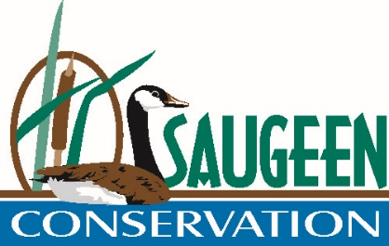
JOB DESCRIPTION
General Manager/Secretary-Treasurer
Purpose of Position
To direct all administration, financial, technical, and field operations of the Saugeen Valley Conservation Authority (SVCA) as the General Manager/Secretary-Treasurer.
To develop and maintain an effective program designed to further the conservation, restoration, development, and management of the natural resources of the watershed(s) of SVCA.
Reporting Relationship:
The SVCA GM/S-T reports to the Chair, Vice-Chairs and Directors of the SVCA.
Job Requirements:
- Education
  - Honours University Degree in Conservation or Resource Management discipline or other related field, or commensurate experience.
- Technical Knowledge
  - Extensive knowledge of principles and practices of natural resource management on a watershed basis
  - Extensive knowledge of provincial, municipal, and conservation authority legislation and regulation acquired through progressively responsible experience
  - Detailed knowledge of SVCA programs and finances
- Skills
  - Demonstrated administration experience and ability
  - Organizational, managerial, and staff development abilities
  - Strong communication, tact, and good judgement
  - Ability to maintain good working relationship with SVCA Directors, elected representatives, and staff of municipalities, counties, and provincial ministries
  - Ability to direct the total program of the SVCA
  - Initiative
  - Strong customer service orientation
  - Strong decision making and strategic planning skills
  - Demonstrated ability to manage through change
  - Versatility under changing conditions
  - Ability to deal with stress and mental fatigue
  - Valid Ontario Class “G” Drivers Licence
Responsibilities:
- Program Administration Coordinator (50%)
  - General supervision of all staff, agents, and consultants
  - Co-ordination and prioritization of the projects of SVCA and ensuring necessary staffing for such projects
  - Adhere to Strategic and Operational Plan for SVCA
  - Co-ordination of preparation of reports, briefs, and technical documents
  - Overall administration of technical, financial, operational, and political aspects of SVCA programs and projects
  - Review staff performance, promotions, and salaries
  - Control over all budget expenditures as approved by the SVCA Board of Directors
  - Encourage development of future program areas and direction
  - Oversee all official business of SVCA
- Liaison (30%)
  - Meet with staff and Councils of member municipalities and counties with respect to past, present, and future programs and projects
  - Maintain liaison with SVCA Board of Directors
  - Deal with representatives of government ministries pertaining to program direction, project approval, funding levels, and operational audits
  - Collaboration with peer groups locally, and at Conservation Ontario
- Public Awareness and Other (20%)
  - Provide formal definition of SVCA programs, procedures, and positions by various communications mechanisms
  - Interpret SVCA policy and instructions
  - Act as Freedom of Information and Protection of Privacy Officer
  - Other duties as may be assigned
Working Conditions:
Works in the administrative centre of SVCA located in Formosa, Ont. with occasional site visits to SVCA properties, out of town meetings, council meetings, Conservation Ontario meetings, etc. Must balance and maintain accessibility to staff, directors, and the public.
Some weekend / evening work required.
Contacts:
Regular and frequent contact with the Chair, Vice Chairs, and Directors of SVCA, municipal, county, and provincial staff, media, and concerned members of the public.

