NOTICE OF PUBLIC MEETING - WE WANT TO HEAR FROM YOU
WHAT: The County and Town are seeking input on development applications within 120 metres of your property that would create 12 lots for commercial lodges, and a future development block.
SITE: 138 Kandahar Lane (geographic former Township of Collingwood, Concession 2, Part Lot 19 RP 16-R-2119 Part 2), Town of The Blue Mountains

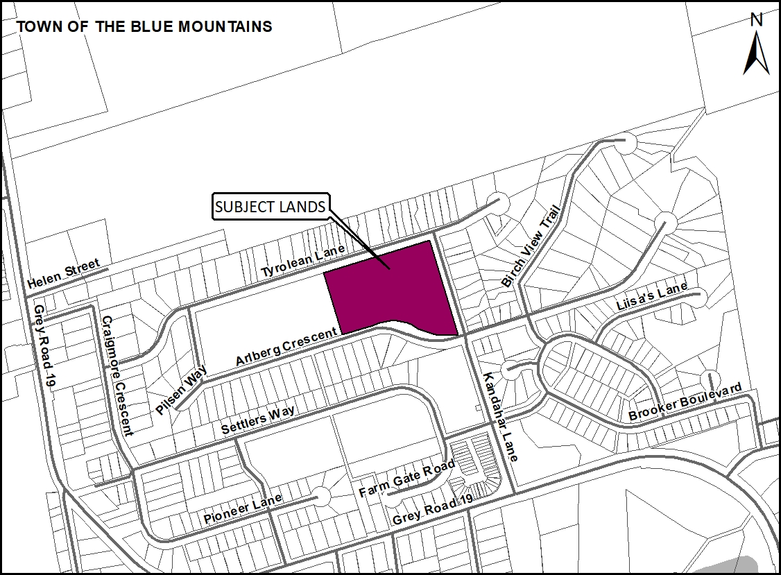

Public Meeting Location: Town of The Blue Mountains, Virtual (Microsoft Teams), 32 Mill Street, Thornbury, ON, N0H 2P0
Timing of Public Meeting: Monday, February 7th, 2022 at 1:00 p.m.
How can I contribute my opinion?
To provide your comments or questions in writing, use email or regular letter mail to the Town Clerk. Written comments received by February 6th, 2022 will be read by the Town Clerk at the Public Meeting and will be included in the record of the Public Meeting.
This Public Meeting will be held virtually. Those that wish to make verbal comments virtually are required to pre-register with the Town Clerk, no later than February 4th, 2022.
The meeting will be also live broadcasted on the Town’s website and posted as a video following the public meeting.

How do I submit comments?
Contact the Town Clerk to pre-register or submit comments to townclerk@thebluemountains.ca or by calling the Town at 519-599-3131 extension 232 or Fax: (519) 599-7723

Comments by mail: Town Clerk, Town Hall, 32 Mill St. Box 310, Thornbury ON, N0H 2P0

Request for Information
For information on the applications visit https://www.grey.ca/planning-development/planning-applications or https://www.thebluemountains.ca/current-projects/planning-development-projects or contact:

 | Scott Taylor (Grey County Planner) |  | Natalya Garrod (Town of The Blue Mountains Planner)
 | County of Grey  595 9th Avenue East  Owen Sound, ON, N4K 3E3 |  | Town of The Blue Mountains  32 Mill Street, P.O. Box 310, Thornbury, ON, N0H 2P0
 | scott.taylor@grey.ca |  | planning@thebluemountains.ca
 | 519-372-0219 ext. 1238 |  | 519-599-3131 ext. 288

What is being proposed through the applications?
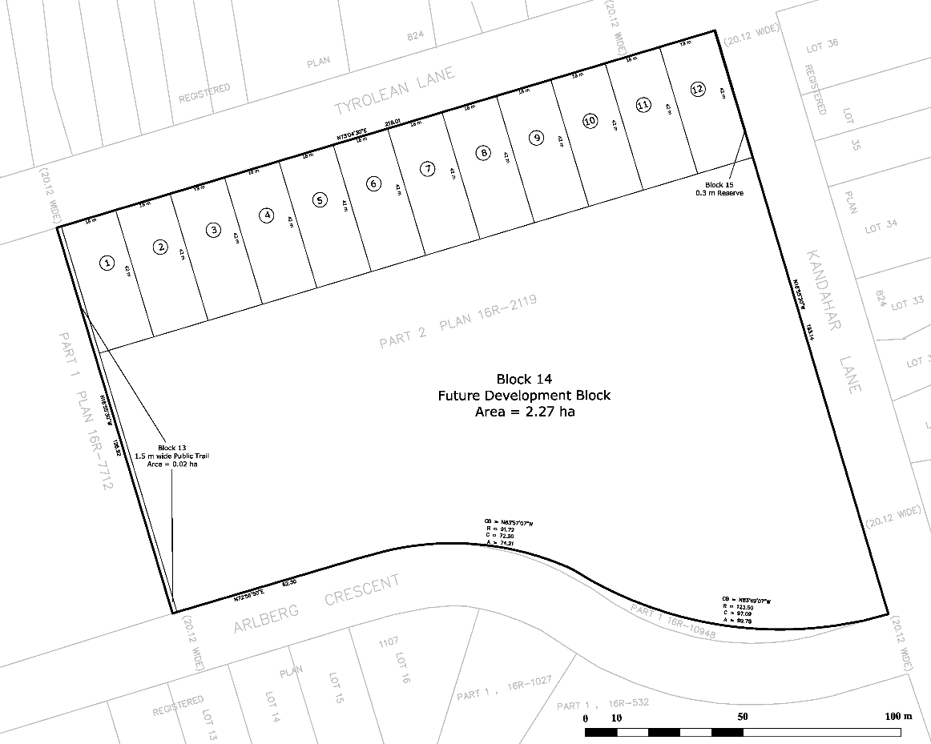
The County has received a plan of subdivision application, known as the 138 Kandahar Lane (County file number 42T-2021-07) to create 12 lots and a future development block. Each of the lots is proposed to contain a commercial lodge with a frontage of 18 m, depth of 42 m and a lot area of 756 m². The plan contains a 1.5 m public trail dedication and a 2.27 ha future development block. Access to the new lots would be via Tyrolean Lane. Servicing to the proposed subdivision will be via existing municipal water and future sewer services. The subject lands are designated as ‘Recreational Resort Area’ in the County Official Plan and the Town Official Plan, which permits new commercial and residential development.
The purpose of the zoning by-law amendment application is to allow for commercial accommodation uses to be permitted. The effect is to re-zone the subject lands from Development ‘D’ zone, Commercial ‘C4-157’ zone and Open Space ‘OS2’ zone to Commercial Exception ‘C3-X’ zone and Development ‘D’ zone. The proposed zoning is similar to Resort Residential ‘RR’ zone provisions of the 2021-59 By-law with the exception of the height and the lot frontage. The Development ‘D’ zone will be applied to the future development block lands.

What can I expect at the Public Meeting?
The public meeting is an opportunity for members of the public to learn more about the proposed development. Attendees have the opportunity to hear a brief presentation about the development, ask questions, and/or make statements either in favour of, or in opposition to the development.
The public meeting will take place at a Council meeting and the moderator will keep the meeting in order and allow the applicant (and their development team), the public, and members of Council to speak and ask questions.
Why is this future Public Meeting being held and what are your rights?
Within Ontario the planning and development process is an open and transparent process, where opinions from all individuals and groups are welcomed. By law municipalities must hold a public meeting, and this meeting is just one of your chances to learn about the development proposal and offer your opinions. Under the legislation governing this development process, which is sections 34 and 51 of the Planning Act, you have the following rights:
- Any persons may attend the public meeting and/or make written or verbal representation either in support of or in opposition to the proposed zoning by-law amendment or plan of subdivision.
- If a *person or public body would otherwise have an ability to appeal the decisions of the Town of The Blue Mountains or the County of Grey to the Ontario Land Tribunal but the person or public body does not make oral submissions at a public meeting or make written submissions to Town of The Blue Mountains before the zoning by-law amendment is approved or refused, or to the County of Grey before the plan of subdivision is approved or refused, the person or public body is not entitled to appeal the decisions.
- If a *person or public body does not make oral submissions at a public meeting or make written submissions to the Town of The Blue Mountains before the zoning by-law amendment is approved or refused, or to the County of Grey before the plan of subdivision is approved or refused, the person or public body may not be added as a party to the hearing of an appeal before the Ontario Land Tribunal unless, in the opinion of the Tribunal, there are reasonable grounds to do so.
- If you wish to be notified of the decision by the Town of The Blue Mountains in respect to the approval or refusal of the zoning by-law amendment, or the County of Grey in respect to the approval or refusal of the plan of subdivision, you must make a written request to the Town or the County, at the addresses noted on the previous page. Please note application P3084 for the zoning by-law amendment when directing comments to the Town and plan of subdivision application 42T-2021-07 when directing comments to the County.
- If you have any questions please do not hesitate to contact County or Town staff, who would be happy to answer any questions on the matter.
*Notwithstanding the above, only a ‘person’ listed in subsection 51(48.3) of the Planning Act may appeal the decision of the County of Grey to the Ontario Land Tribunal (OLT) as it relates to the proposed plan of subdivision. Below is the prescribed list of ‘persons’ eligible to appeal a decision of the County of Grey related to the proposed plan of subdivision as per subsection 51(48.3) of the Planning Act. These are recent changes that have been made to the Planning Act by the province. A link to the revised Planning Act can be found here - https://www.ontario.ca/laws/statute/90p13. For more information about these recent changes, please visit the OLT website or contact OLT - https://olt.gov.on.ca/about-olt/
The prescribed list of ‘persons’ eligible to appeal a decision of the County on the proposed plan of subdivision as per subsection 51(48.3) of the Planning Act is as follows:
- A corporation operating an electric utility in the local municipality or planning area to which the plan of subdivision would apply.
- Ontario Power Generation Inc.
- Hydro One Inc.
- A company operating a natural gas utility in the local municipality or planning area to which the plan of subdivision would apply.
- A company operating an oil or natural gas pipeline in the local municipality or planning area to which the plan of subdivision would apply.
- A person required to prepare a risk and safety management plan in respect of an operation under Ontario Regulation 211/01 (Propane Storage and Handling) made under the Technical Standards and Safety Act, 2000, if any part of the distance established as the hazard distance applicable to the operation and referenced in the risk and safety management plan is within the area to which the plan of subdivision would apply.
- A company operating a railway line any part of which is located within 300 metres of any part of the area to which the plan of subdivision would apply.
- A company operating as a telecommunication infrastructure provider in the area to which the plan of subdivision would apply.
A note about information you may submit to the Town or the County: Under the authority of the Municipal Act, 2001 and in accordance with Ontario's Municipal Freedom of Information and Protection of Privacy Act (MFIPPA), all information provided for, or at a Public Meeting, Public Consultation, or other Public Process are considered part of the public record, including resident deputations. This information may be posted on the Town or County websites, and/or made available to the public upon request.
This document can be made available in other accessible formats as soon as practicable upon request.
Dated at the County of Grey 10th day of January, 2022.

