Grey County Logo Committee Report

|  |  |
| --- | --- |
| **To**: | Warden McQueen and Members of Grey County Council |
| **Committee Date**: | September 10, 2020 |
| **Subject / Report No**: | TR-CW-09-20 |
| **Title**: | Grey County Roads 19/21 Project Update |
| **Prepared by**: | Pat Hoy, Director of Transportation Services |
| **Reviewed by**: | Kim Wingrove, CAO |
| **Lower Tier(s) Affected**: | The Blue Mountains |
| **Status**: | Recommendation adopted by Committee as presented per Resolution CW154-20; Endorsed by County Council September 24, 2020 per Resolution CC75-20; |

# Recommendation

1. **That Report TR-CW-09-20 Grey County Roads 19/21 Project Update be received; and**
2. **That Council direct staff to negotiate an agreement in principle with the Town of the Blue Mountains regarding cost sharing for the relocation and reconstruction of the water booster station and to be brought back to a future Council meeting for approval.**

## Executive Summary

The intersection of Grey Roads 19 and 21 (Simcoe Road 34) is 1 km east of Blue Mountain Resort on the west boundary of the Town of Collingwood. Significant residential development and expansion of the Resort has resulted in increases in traffic volume and long delays at peak travel times. Grey County, in collaboration with Simcoe County and the Town of the Blue Mountains has been working towards the completion of intersection improvements since 2011. The project is very complicated due to property issues, development in the area, numerous utility matters, multiple stakeholders and personnel changes which caused delays in agreeing on a final design for the intersection.

The purpose of this report is to outline the details surrounding the status of the project and the proposed steps required for completion of the intersection improvements.

## Background and Discussion

At this time, the 90% detailed design of the intersection as a roundabout has been forwarded to the utilities (in March 2020) with their relocation designs to be completed in early 2021. The construction of a water booster pump station by the Town of the Blue Mountains must be completed before 2022 and utility relocation is anticipated in 2021. Construction of the roundabout at GR19/21 is expected to be completed in 2022. It is anticipated the majority of the roundabout construction will be completed in 2022 with some work carrying over to 2023. The project will cost approximately $4.1M, with Simcoe County contributing $1.56M and development charges making up the balance. Since 2015, approximately $70,000 has been paid to consultants in the planning and engineering of the project.

### History of the Grey Road 19 (Simcoe Road 34) and the Grey Road 21 Intersection

On February 17, 2011, representatives for RJ Burnside completed a presentation to the Transportation and Public Safety (TAPS) Committee about the future intersection at Grey Road 19 and Grey Road 21. This presentation outlined a potential ten-year life span of adding additional lanes and a twenty plus year life span of adding a multi-lane roundabout. The meeting minutes indicated further conversations would need to be held regarding the future intersection improvements.

In 2011, the Grey Road 19 / Grey Road 21 roundabout project was placed on the five-year capital plan for 2012-2013, with a total budget of $4.3 million.

By 2012, the Grey Road 19 / Grey Road 21 roundabout project was listed on the five-year capital plan for 2015, with a total budget of approximately $500,000. At this time, it was anticipated that signals were the preferred option.

### Grey Road 19 and Grey Road 21 Class Environmental Assessment and Intersection Design

On December 4, 2014, Grey County closed RFP-TS-19-14 for the class environmental assessment and intersection design for the Grey Road 19 and Grey Road 21 intersection. This Schedule B Assessment was awarded to C.C. Tatham. The original Request for Proposal indicated that the design, cost estimate and conservation authority permit was to be completed by August 28, 2015.

A Public Information Centre was held on March 14, 2015, with the recommended option for the intersection being Option 2: traffic signals and additional lanes. At this time, although from traffic, transportation and safety a roundabout was preferred, it was thought to not be economically feasible, so Option 2: traffic signals and additional lanes was selected.

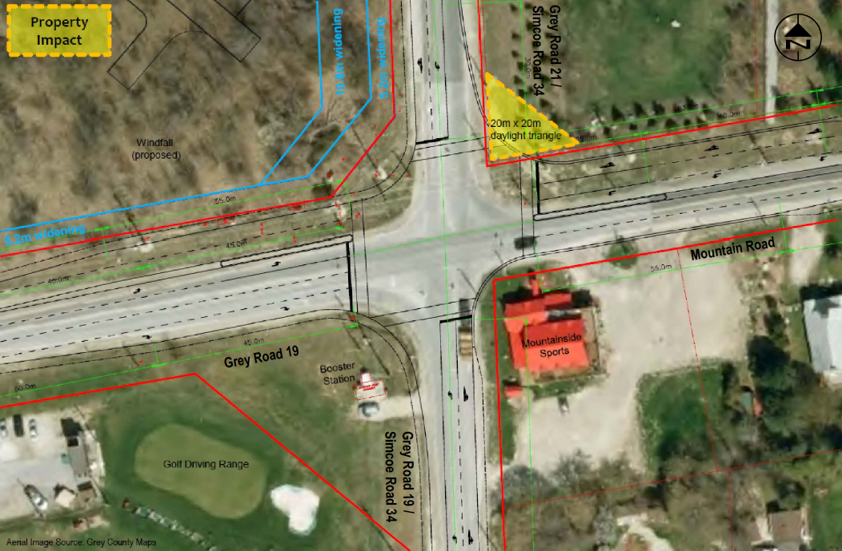By 2015, the Grey Road 19 / Grey Road 21 intersection was in the capital plan schedule for 2017 and included the rehabilitation south of the intersection. The capital amount (total budget) was just under $1.4 million.

In spring 2016, Grey County met with Simcoe County. Both parties had witnessed significant growth in the area and had witnessed the effectiveness of newly built roundabouts in Simcoe County. At that time, Grey County asked C.C. Tatham to re-open the environmental assessment to look at the roundabout alternative again. Grey County and Simcoe County wanted to ensure that the configuration would have a long window to satisfy demand. The signalized intersection would only satisfy capacity until approximately 2025.

Throughout the updated Environmental Assessment, C.C. Tatham and Grey County investigated alternative locations. These were summarized in Staff Report TC-CW-35-18 with the following endorsed by Grey County Council on July 12, 2018.

1. *That Report TR-CW-35-18 regarding the intersection of Grey Road 19 and Grey Road 21 be received; and*
2. *That Grey County proceeds with an intersection roundabout design.*

### Utility Relocations

Grey County also met onsite with several utilities in 2017. They indicated that moving the utilities would be a multi-year process, with up to a year to design their relocations. The following year would be used to move the utilities. Utilities in the area include Bell, Enbridge, Hydro One, EPCOR and Rogers. The utilities are currently working on utility relocation designs with an anticipated move scheduled in 2021.

### Pumping Station

The Blue Mountains has an underground water booster pump station within the intersection installed in 2004. The anticipated life of that asset (prior to large part repairs) was likely in the 20-30 year range. As part of the project, a new above ground station will need to be constructed and in place prior to the existing one being removed. There is property available/property will need to be acquired for this purpose. The cost of construction for the booster pump station alone will likely be well over $1,000,000. There are no other viable alternatives to locating the pump station at the intersection. There was no agreement when the station was installed indicating who is responsible for the costs of future relocates, so Grey County and The Blue Mountains could be expected to enter into a cost sharing agreement.

### Area Developments

Georgian Communities (the developer) and Grey County agreed that a roundabout would eventually be constructed by the developer at the intersection of Grey Road 19 and Crosswinds Boulevard. Grey has recently asked that temporary signals be placed in the fall of 2020, as the intersection is exhibiting long delays with a stop sign. This will become more necessary as Crosswinds Boulevard eventually leads to the intersection of Jozo Weider Boulevard and Grey Road 19.

Mountain House is the name of the condominium development at the north west corner of Grey Road 19 and Grey Road 21. The consultant and developer have worked with Grey County to incorporate the future roundabout into the design. Grey County has made every effort to not slow down the developer from getting to the final stages of their site. The developer has agreed to build a northbound left turn lane on Grey Road 21. It will be incorporated into the roundabout design and contract.

### Future Area Upgrades

The expansion of Grey Road 19 to four lanes between Grey Road 119 and Grey Road 21 has been included in Grey County’s Development Charges since they began. However, no previous study had been completed to determine a more accurate date for these expansions (based on traffic and developments).

In 2019 Grey County secured the services of R.J. Burnside and Associates to determine a construction year for four lane expansion. The study recommended the following by 2030:

* That the County proceed to with the two-lane roundabout at Crosswinds Boulevard by 2022 (although this may end up being 2023).
* That by 2025, Grey County completes the four-lane cross-section on Grey Road 19 between Crosswinds Boulevard and Grey Road 21
* By 2025, warrants will be met for a left turn lane at Claire Glen Road.
* By 2030 Grey County completes a four-lane cross-section on Grey Road 19 between Crosswinds Boulevard and the Grey Road 119 roundabout.

Traffic Counts completed in January 2019, showed peak hour counts of near 800 vehicles, with the maximum for an arterial road of this class being somewhere from 800 to 1200.

R.J. Burnside and Associates will assess the remainder of Grey Road 19 and Grey Road 21 by the end of 2020.

The Blue Mountains is also undertaking a drainage plan to resolve issues in the area of Grey Road 119 and Grey Road 19. Grey County will be replacing a culvert east of the existing roundabout, due to the drainage improvements. Grey County will install a (box) culvert that will accommodate the future four-lane road at that time.

There has currently been no municipal class environmental assessment completed for the expansion of Grey Road 19 to four lanes. Grey County will be closing an assignment shortly to begin the Environmental Approval process. As shown on the attached plan, the distance between the two roundabouts is only a few hundred meters, and it would be ideal if it could be completed as part of one (possibly multi-year) contract. Grey County, Simcoe County, The Blue Mountains and Georgian Communities will continue to coordinate timing of the tenders to complete the projects in the most efficient manner. Consultation with Blue Mountain Resort will also be undertaken regarding the scheduling of the construction periods each year. The potential schedule is as follows with items 3-6 potentially issued under one contract.

|  |  |  |  |
| --- | --- | --- | --- |
| Item | Description | Construction Year | Responsible |
| 1 | Temporary signals at Crosswinds Blvd. | 2020 | Georgian Communities |
| 2 | Utility relocations at Roundabout | 2021 | Grey/Simcoe |
| 3 | Grey Road 19/21 Roundabout | 2022 | Grey/Simcoe |
| 4 | Mountain House left turn lane | 2022 | Georgian Communities |
| 5 | Crosswinds Roundabout | 2023 | Georgian Communities |
| 6 | Four laning Grey Road 19 from 19/21 to Grey Road 119 | 2023 | Grey County |

Simcoe County is about to begin acquiring all of the land needed for the roundabout at Grey Road 19 and Grey Road 21. There is land required in multiple locations. Some has already been acquired from Mountain House, while some is yet to be obtained.

Grey County will need to acquire land for the Crosswinds Boulevard roundabout and for the four-lane widening.

## Legal and Legislated Requirements

Grey County has completed an agreement with Georgian Communities for the funding of the northbound left turn lane into Mountain House.

Grey County will need to finalize an agreement regarding the Crosswinds Boulevard roundabout.

Grey County will need to enter into a cost sharing agreement with Town of the Blue Mountains regarding the relocation of the water booster pump station.

## Financial and Resource Implications

The current Grey County ten-year capital estimated costs are shown below:

|  |  |  |  |  |
| --- | --- | --- | --- | --- |
| **Project** | **Funding Source** | **2021** | **2022** | **2023** |
| Grey Road 19 and Grey Road 21 Intersection |  | $1,020,000 | $3,121,200 |  |
|  | DC Category 5 - Bridges and Culverts |  | ($17,100) |  |
|  | Simcoe County | ($510,000) | ($1,560,600) |  |
|  | Grey Road 19 and 21 Intersection Reserve |  | ($288,000) |  |
|  | DC Cat. 4 - Intersection Improvements | ($326,700) | ($999,600) |  |
| Grey Road 19 Four-Lane Expansion Grey Road 119 - Grey Road 21 |  |  |  | $5,093,800 |
|  | DC Category 5 - Bridges and Culverts |  |  | ($12,800) |
|  | OCIF Funding |  |  | ($1,279,900) |
|  | DC Category 1 - Major Road Expansions |  |  | ($3,460,400) |

The roundabout project costs will continue to be updated as utility relocation designs and pumping station designs advance.

# Relevant Consultation

Internal  
Planning Department

External  
County of Simcoe  
The Blue Mountains  
Georgian Communities

### Appendices and Attachments

[Grey County Transportation Issues, Blue Mountain Area, December 14, 2011, RJ Burnside](https://docs.grey.ca/share/public?nodeRef=workspace://SpacesStore/b7b577c1-bb0f-4bd2-ab80-a863591e428d)  
[TR-CW-35-18 Grey Road 19 and Grey Road 21 Intersection Options](https://docs.grey.ca/share/public?nodeRef=workspace://SpacesStore/5150aed8-49e4-43ed-b605-67ba2bf6c9f5)   
Grey Road 19 / Grey Road 21 Future Plan Works Drawing

### Grey Road 19 / Grey Road 21 Future Plan Works Drawing

