Grey County Logo Housing Newsletter

Winter 2020

# Dental Program for Seniors



The new Ontario Seniors Dental Care Program is a government-funded dental care program. It provides free, routine dental services for low-income seniors who are 65 years of age or older. Coverage includes: check-ups, including scaling, fluoride and polishing.

For more information on this program, please speak to your Community Relations Worker or visit [www.ontario.ca/SeniorsDental](http://www.ontario.ca/SeniorsDental) or contact the Health Unit at 519-376-9420, and press 8 for dental.

# New Staff

**Sharon Irwin** has joined our team as our Tenant Services Coordinator.  Sharon will assist our Department with lease agreements and maintaining tenancy through creative interventions.  Sharon is very experienced in the Housing/Human Services field having previously worked as a Property Manager, and most recently working with the Y-Housing as a Housing Support Worker.  Sharon will work alongside Cathy Snyder in her role.

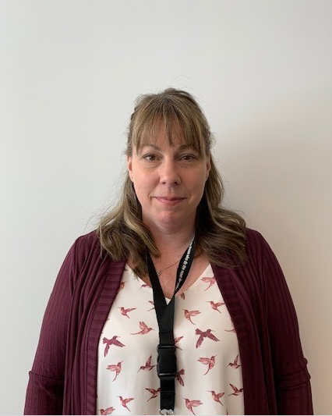

**Meghan Kerry** joins our team as our Outreach Housing Worker.  Meghan will assist our Department with Outreach and Community Relations.  Meghan comes to us with a diverse experience in Housing, Homelessness, outreach, addictions and mental health. Meghan will work alongside Nadia Ellis in her role.  This position is a partnership between Canadian Mental Health Association (CMHAGB) and Grey County Housing.



# Tax Clinics

It is important to file a tax return to get Ontario tax credits and benefits. Even if you received social assistance or didn’t earn income, you could get money back by filing a tax return.

Need a hand? If you have a modest income, tax-filing help is available at cra-arc.gc.ca/volunteer or 1-800-959-8281 Ontario.ca/taxcredits – 1-866-ONT-TAXS

# After Hour Emergencies

For all after hours emergencies, please call 519-376-5744 and press #1 to reach the after hours contact.

# Icicles can be dangerous

Falling ice in the winter can cause serious injuries. With fluctuating temperatures, we often see periods of freeze-thaw-refreeze. An associated hazard during thaw periods may be falling ice and snow from elevated surfaces.

# Tenant Meetings

Housing staff will be scheduling upcoming tenant meetings in the buildings in the spring. Scheduled dates and times of the meetings will be posted in the buildings in the coming weeks.

# Emergency Management Portal

Grey County’s Emergency Management Portal is your one-stop hub in the event of a declared county emergency. Stay connected with the most important emergency alerts and details and use convenient links to other important websites. <https://emportal.grey.ca/>

# Retirement

# After 9 years with the County, Sally Morris (Waitlist Coordinator) is retiring. We wish Sally all the best as she starts her new adventure.

# Eliminate Winter Germs

Remember that we are all more prone to coughs and colds during the winter. To help prevent the spread of unwanted germs, regular cleaning and handwashing is recommended. Hard surfaces such as kitchens and bathrooms should be wiped down with disinfectants.

# Safety Tips



**For pedestrians:**

* Be aware of your surroundings. If wearing a hat or hood, make sure you can still see the roads, sidewalks, traffic signs and other people properly
* Always make eye contact with drivers and cyclists before crossing the road.
* Wear bright, reflective clothing at night or when visibility is poor.
* Don’t “jaywalk”. Cross the street at crosswalks and obey traffic signals
* Pay attention. Don’t text/read/play games on your phone while walking.

**In your home:**

* Don’t pour cooking oil down the sink, toilet or drain. It can clog the pipes in your building.
* Stay in your kitchen when using the stove. Turn your stove off if unattended.
* Stay alert and don’t cook if you are sleepy, fatigued or drowsy.

# Office Hours

Our office hours are Monday – Friday from 8:30am – 4:30pm

Phone: 519-376-5744

Fax: 519-376-0445

Email: [housing@grey.ca](mailto:housing@grey.ca)

If you have an emergency after hours such as no heat or beeping smoke detector or a flood please contact

519-376-5744 x1.