Grey County Logo Housing Newsletter

Fall 2019

# National Housing Day 2019

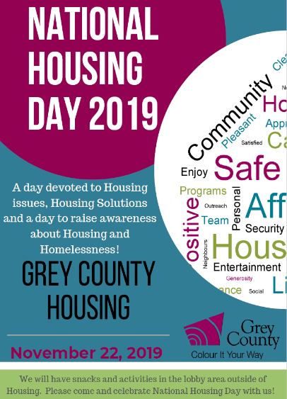National Housing Day is a day devoted to Housing issues, Housing Solutions and a day to raise awareness about Housing and Homelessness! Please help us celebrate National Housing Day. There will be snacks and activities in the lobby of the Grey County Administration building on November 22nd, 2019.

# Halloween

We hope that everyone had a safe and fun Halloween. Grey County Housing staff dressed as bumper cars for the annual Grey County Halloween contest. Our team was excited to claim first prize in the competition.

# Maintaining Heat in your Unit

[](https://www.hydroone.com/RatesAndBilling_/Documents/TOU_Bill_Insert_Fall_2019.pdf)

Heating homes accounts for over 70% of household energy consumption. So reducing this figure – while keeping homes warm enough can assist in cutting down your energy bills. Below are some tips to keeping heat in your unit during the cooler months:

* Open curtains during the day to let the sun in
* Move furniture away from heaters
* Keep windows closed
* Ensure the heat remains on and at an adequate temperature in the unit

# Cannabis

Our Housing locations began the transition to smoke-free in 2014. The Smoke free lease clause includes anything that generates smoke.

The legalization of recreational cannabis through Bill C-45 the Federal Cannabis Act permits the cultivation of up to four cannabis plants per household. Grey County has banned cannabis cultivation in County owned housing units to proactively address potential issues. The policy will work in conjunction with Grey County Housing’s Smoke Free policy to continue to provide reasonable enjoyment for all tenants. Grey County Housing will take reasonable steps to enforce the smoke-free policy.

# Coming Winter Season

The season is coming for snow removal and while we appreciate our tenants thoughtfulness in helping out, Custodial staff ask that residents do not aid with snow removal due to the risk of injury. To help out, please make sure you shake all the snow off your boots before entering the main lobby to keep the space clean and dry and reduce the risk of slips.

Public Libraries

Did you know library cards to our local libraries are free? You can sign up online or in person at any library. With the cold weather rolling in, libraries host many programs for all ages, along with many other services such as:

* Access to an Internet-enabled computer or laptop
* Career Resources
* Borrowing of library books, magazines, movies and music albums

cid:image001.jpg@01D59577.3283C140Dental Work and Dentures

* Looking for low cost dental work and dentures? Did you know that Georgian College Oral Health Clinic in Barrie provides a variety of dental services to the public at a low cost, including dental hygiene, restorative and denture services. To find out more contact them at 705-722-5114

# Fire Safety is Everyone’s Responsibility

Careless smoking is the leading cause of fire deaths. Help prevent fires caused by careless smoking.

* If you smoke, use only fire-safe cigarettes, and always smoke outside
* Never throw cigarette butts off a balcony.
* Never smoke in bed or when drowsy, intoxicated or medicated.
* Keep cigarettes, lighters, matches and other smoking materials in a locked cabinet, out of reach of children

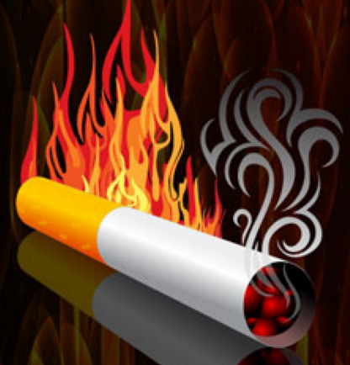

* Never allow anyone to smoke if there is medical oxygen being used.
* Never leave charging e-cigarettes unattended

# Office Hours

Our office hours are Monday – Friday from 8:30am – 4:30pm

Phone: 519-376-5744

Fax: 519-376-0445

Email: [housing@grey.ca](mailto:housing@grey.ca)

If you have an emergency after hours such as no heat or beeping smoke detector or a flood please contact

519-376-5744 x1.