NOTICE OF PUBLIC MEETING – WE WANT TO HEAR FROM YOU
WHAT: The County and Municipality are seeking input on development applications within 120 metres of your property that would consider allowing a 469 unit Plan of Subdivision, Official Plan Amendments, and a Zoning By-law Amendment.
SITE: Part of Lots 95, 96, and 97, Concession 1 NETSR, Municipality of Grey Highlands, formerly in the geographic Township of Artemesia

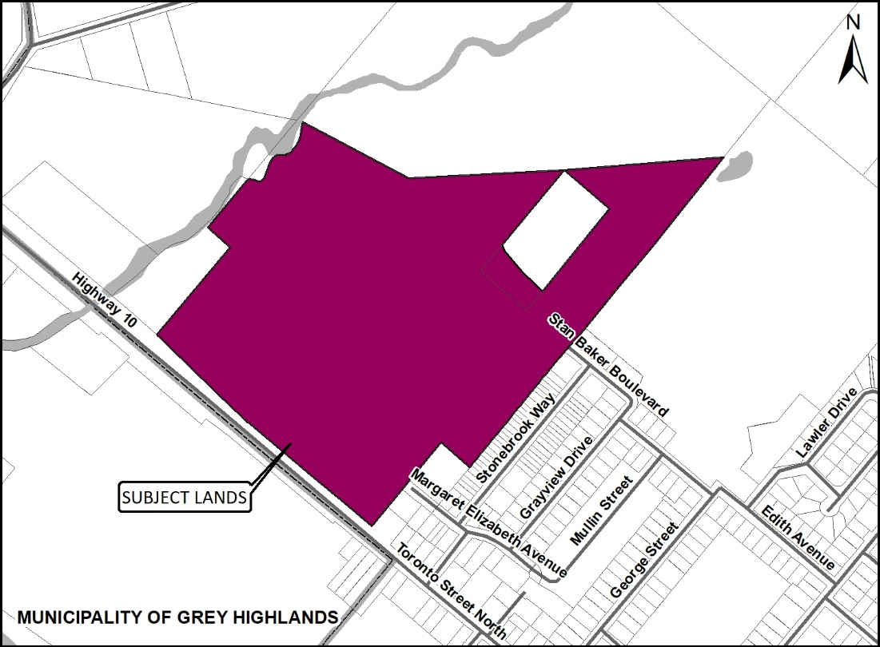

Timing and Location of Public Meeting: Monday June 27, 2022 at 5:00 p.m.
The meeting will be held virtually using the Zoom platform.
Please register virtually to attend the meeting here: https://www.greyhighlands.ca/junepp/
View the meeting live here: https://youtu.be/yd3TRIehrtQ
Your online registration will give you the ability to attend either online or by telephone. If you need assistance with the registration process, or cannot access the registration link, please call 519-986-1216 extension 228.
How can I contribute my opinion?
Any person or agency may attend the Public Meeting and/or make verbal or written comments regarding this proposal.

Request for information:
For information on this development visit:
www.grey.ca/planning-development/planning-applications
https://greyhighlands.civicweb.net/filepro/documents/284195

The documents can also be viewed by visiting the County or Municipal Offices at the addresses below.
How do I submit comments?
Submit written comments or sign-up to be notified of a decision by mailing or contacting:

 | Scott Taylor  County of Grey Planning Department  595 9th Avenue East  Owen Sound, ON, N4K 3E3 |  | Matt Rapke  Municipality of Grey Highlands  206 Toronto Street, PO Box 409,  Markdale, ON, N0C 1H0
 | scott.taylor@grey.ca |  | planning@greyhighlands.ca
 | 519-372-0219 ext. 1238 |  | 519-986-2811 ext. 228

What is being proposed through the applications?
Below is a map showing the proposed Plan of Subdivision. A full version of this map is available on the County or Municipal websites, or at the County offices in Owen Sound, or the Municipal offices in Markdale.
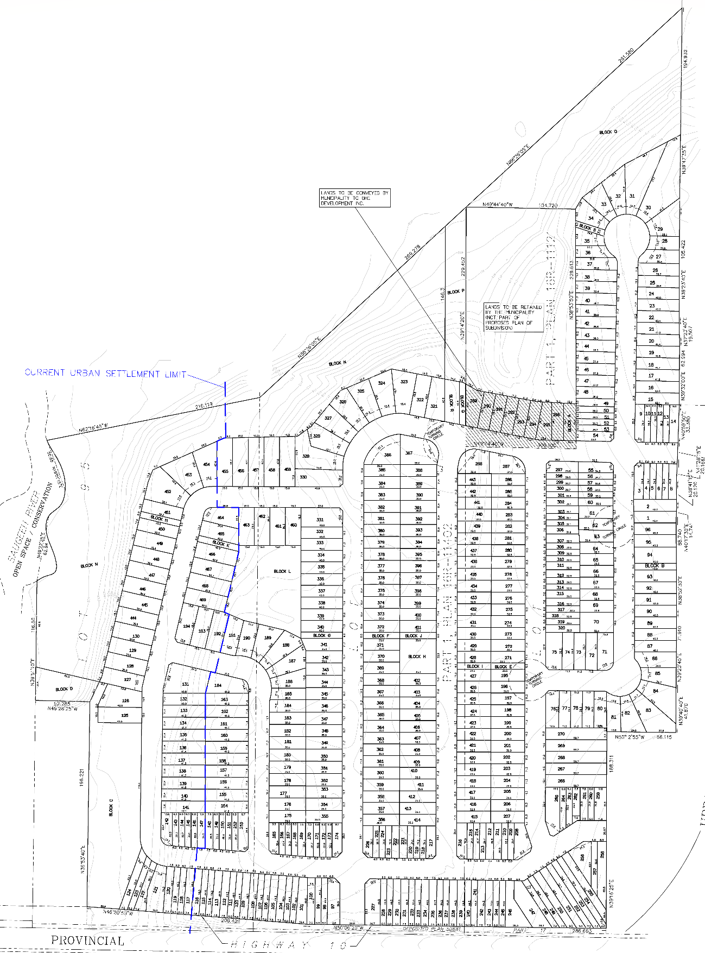
The purpose and effect of the Plan of Subdivision is to create four hundred and sixty-nine (469) new lots, comprising three hundred and thirteen (313) detached residential lots and one hundred and fifty-six (156) multi-attached residential units. New roads, parks, stormwater facilities, and open space blocks would also be created through the Plan of Subdivision.
Official Plan Amendments are also required to both the County and Municipality of Grey Highlands Official Plans. The purpose and effect of the County Official Plan Amendment is to re-designate a portion of lands in the northeastern part of the subject lands from the ‘Rural’ designation to the ‘Primary Settlement Area’ designation to permit new residential development. The purpose and effect of the Grey Highlands Official Plan Amendment is to incorporate the same settlement area boundary change required under the County Official Plan Amendment. The Grey Highlands OP Amendment will provide a more specific designation of “Neighbourhood” to the area subject to the settlement area boundary expansion.
The purpose of the Zoning By-law Amendment is to amend the Municipality of Grey Highlands Comprehensive Zoning By-law No. 2004-50 to rezone the subject lands to implement the 469 unit Plan of Subdivision. The effect of the Zoning By-law Amendment is to change the zone symbol from “Open Space” (OS-10) to special residential zones and open space zones. The new residential zones would fall into several categories to accommodate row town house units, small lot single detached units, standard single detached units, and a flex zone to accommodate both small lot single units and row town house units. The flex zone would not be implemented in Phases 1, 2, or 3. The open space zones would firstly be established for active parkland spaces and pedestrian accessways and secondly for SWM ponds and accessways. It is also anticipated that a Holding zone be established for the lots in part of Phase 3 that fall within the Landfill Restriction area.

What can I expect at the Public Meeting?
The public meeting is an opportunity for members of the public to learn more about the proposed development. Attendees have the opportunity to hear a brief presentation about the development, ask questions, and/or make statements either in favour of, or in opposition to the development. At the meeting members of the public will also hear a summary of any comments received about the proposed development prior to the public meeting.
The public meeting will take place at an online special meeting of Council and the Mayor or Chair will act as the moderator for the meeting. The moderator will keep the meeting in order and allow the applicant (and their development team), the public, and members of Council to speak and ask questions.
This meeting is an opportunity to learn about the proposed development application and provide feedback.

Why is this Public Meeting being held and what are your rights?
Within Ontario the planning and development process is an open and transparent process, where opinions from all individuals and groups are welcomed. By law a municipality must hold a public meeting, and this meeting is just one of your chances to learn about the development proposal and offer your opinions. Under the legislation governing this development, which is Sections 22, 34, and 51 of the Planning Act, you have the following rights:
- Any persons may attend the public meeting and/or make written or verbal representation either in support of or in opposition to the proposed Plan of Subdivision, Official Plan Amendments, or Zoning By-law Amendment.
- If a *person or public body would otherwise have an ability to appeal the decisions of the Municipality of Grey Highlands or the County of Grey to the Ontario Land Tribunal but the person or public body does not make oral submissions at a public meeting or make written submissions to Municipality of Grey Highlands before the Zoning By-law Amendment or Municipal Official Plan Amendment is approved or refused, or to the County of Grey before the County Official Plan Amendment or Plan of Subdivision is approved or refused, the person or public body is not entitled to appeal the decisions.
- If a *person or public body does not make oral submissions at a public meeting or make written submissions to the Municipality of Grey Highlands before the Zoning By-law Amendment or Municipal Official Plan Amendment is approved or refused, or to the County of Grey before the County Official Plan Amendment or Plan of Subdivision is approved or refused, the person or public body may not be added as a party to the hearing of an appeal before the Ontario Land Tribunal unless, in the opinion of the Tribunal, there are reasonable grounds to do so.
- If you wish to be notified of the decision by the Municipality of Grey Highlands in respect to the approval or refusal of the Zoning By-law Amendment (File # Z06.2022), Municipal Official Plan Amendment (File # OP01.2022) or the County of Grey in respect to the approval or refusal of the Plan of Subdivision (File # 42T-2021-08) and County Official Plan Amendment (42-08-180-OPA-12), you must make a written request to the Municipality or the County, at the addresses noted on the previous page. Please note the file numbers noted above when directing correspondence to the Municipality or the County.
- If you have any questions, please do not hesitate to contact County or Municipal staff, who would be happy to answer any questions on the matter.
*Notwithstanding the above, only a ‘person’ listed in subsection 51(48.3) of the Planning Act may appeal the decision of the County of Grey to the Ontario Land Tribunal (OLT) as it relates to the proposed Plan of Subdivision. Below is the prescribed list of ‘persons’ eligible to appeal a decision of the County of Grey related to the proposed Plan of Subdivision as per subsection 51(48.3) of the Planning Act. These are recent changes that have been made to the Planning Act by the province. A link to the revised Planning Act can be found here - https://www.ontario.ca/laws/statute/90p13. For more information about these recent changes, please visit the OLT website or contact OLT - https://olt.gov.on.ca/about-olt/
The prescribed list of ‘persons’ eligible to appeal a decision of the County on the proposed Plan of Subdivision as per subsection 51(48.3) of the Planning Act is as follows:
- A corporation operating an electric utility in the local municipality or planning area to which the Plan of Subdivision would apply.
- Ontario Power Generation Inc.
- Hydro One Inc.
- A company operating a natural gas utility in the local municipality or planning area to which the Plan of Subdivision would apply.
- A company operating an oil or natural gas pipeline in the local municipality or planning area to which the Plan of Subdivision would apply.
- A person required to prepare a risk and safety management plan in respect of an operation under Ontario Regulation 211/01 (Propane Storage and Handling) made under the Technical Standards and Safety Act, 2000, if any part of the distance established as the hazard distance applicable to the operation and referenced in the risk and safety management plan is within the area to which the Plan of Subdivision would apply.
- A company operating a railway line any part of which is located within 300 metres of any part of the area to which the Plan of Subdivision would apply.
- A company operating as a telecommunication infrastructure provider in the area to which the Plan of Subdivision would apply.
A note about information you may submit to the Municipality or the County: Under the authority of the Municipal Act, 2001 and in accordance with Ontario's Municipal Freedom of Information and Protection of Privacy Act (MFIPPA), all information provided for, or at a Public Meeting, Public Consultation, or other Public Process are considered part of the public record, including resident deputations. This information may be posted on the Municipal or County websites, and/or made available to the public upon request.
This document can be made available in other accessible formats as soon as practicable upon request.
Dated at the County of Grey 20th day of May, 2022.

